**Investigation – Philip Mortimer**

**Stakeholders and Their Requirements**

The West Cross Chess Club is an informal gathering of a group of friends who play chess together on a fortnightly basis. The club is normally hosted at one of the members’ houses or outside by picnic benches and the members typically play one or two games per session. The sessions sometimes include brief discussion of strategy such as desirable opening moves and situations from which a checkmate can be achieved. The club is open to anyone. Due to the COVID-19 pandemic, the club has been unable to meet as normal and have resorted to playing chess online. The members make use of chess.com to play chess against each other and talk to each via Discord (an application that allows users to make video and audio calls through the internet). Even once the club returns to normal sessions, they wish to continue with online play (in addition to in person sessions) as it provides greater flexibility and convenience. The club is organised and led by Lewis James and has about 10 members at the moment. The club will be looking for a system that allows them to play chess online against fellow members but also allow users to play offline games against people or a computer (something which cannot be done through chess.com). The system will not require a large amount of end users as the club consists of about 10 members. In addition to allowing online play, James would like to ability to add and delete member details from the system and for the system to schedule games. There are clearly two different stakeholders in this project: the club organiser and club members. The organiser, Lewis James, want a system to schedule chess games and have the system collect results from these games to update a league table. James needs the ability to add and remove members from the club. All members want the ability to play against other members and against a computer to hone their chess skill and participate in the club. West Cross Chess Club members and the West Cross Chess Club users are the two stakeholders and types of user. Lewis James is my client whilst the Club members and Lewis James are the users.

**Investigation of the Current System**

The current system involves chess players playing games against each other once every fortnight via chess.com. James, the leader of the club, uses Discord to organise who is playing who. One of the two members who is playing invites the other to the game. This is done via a hyperlink that the website creates. The two members can choose to be on an audio call together through the use of Discord. To gain this information and more, I interviewed Lewis James (the leader of the West Cross Chess Club). A transcript of the interview can be found below.

Philip Mortimer: Hello.

Lewis James: Hi there.

Philip Mortimer: Hi Lewis. So, I’m, just going to ask you a few questions about your chess club. Could you please tell me a bit about your club and how you guys meet and play?

Lewis James: Of course. We’re a group of about 10 friends who normally meet once every two weeks on a Tuesday for about an hour / hour and a half in the evening. The club is a pretty social affair and we often have a chat over a drink whilst playing a game of chess. We normally only play one game per session and are not very competitive.

Philip Mortimer: You mention that you’re not very competitive, do you play towards any goal or is it just a set of individual matches every other week?

Lewis James: We do have a system that keeps track of the results of each game. We have a league table system, similar to the football where a win is worth three points, a draw worth one and a loss worth zero. Once everyone has played each other twice, the table is reset. The winner is typically treated to a meal by everyone else. However, we are not very competitive with the table and the focus is definitely much more social.

Philip Mortimer: That sounds fun. Do you ever discuss chess, or do you just play?

Lewis James: I do occasionally prepare discuss tactics for a little bit of the sessions. It doesn’t happen too often, but we do sometimes discuss good moves and things like that.

Philip Mortimer: Where does the club meet?

Lewis James: If it’s sunny, we like to go outside and sit on a set of benches. However, if it’s not we typically go round a member’s house for the session.

Philip Mortimer: How has COIVD-19 impacted the club?

Lewis James: The virus has meant that we haven’t been able to meet in person since lockdown. Even as restrictions have been eased, we still haven’t resumed sessions yet because some members are not comfortable touching the pieces and sitting close to each other. We have managed some online sessions though.

Philip Mortimer: How has the club played online?

Lewis James: We’ve been playing together using an online chess website. We’ve essentially been sticking to the timetable of every other Tuesday just digitally.

Philip Mortimer: What website have you been using to play chess?

Lewis James: We play on chess.com.

Philip Mortimer: So how does it work in the context of your club? How do you organise matches and play against each other?

Lewis James: The website gives you a hyperlink that lets a friend play against you. You have to send the link to the person you would like to play against. That person clicks the link and you play against each other.

Philip Mortimer: How do you arrange who is going to play who and sort out the league table?

Lewis James: At the moment we use Discord. I have a spreadsheet keeping track of who has played who and what the outcome was. I use this and post the league table every other week in Discord. I publish the schedule for a given session and the people who are playing each other arrange when they are going to play their game. Once the game is finished, they tell me the result and I update the table.

Philip Mortimer: How has the social aspect of the club been impacted when playing online?

Lewis James: It’s obviously not the same as before, but the experience is still there. The two people playing against each other often call each other whilst playing and have a chat. In fact, it is more sociable in some ways as more people are able to play their games because of the flexibility provided by playing online.

Philip Mortimer: Do the members call each other by phone?

Lewis James: Yeah, some do. Others also use Discord to call each other, it varies.

Philip Mortimer: How has your experience with online play been?

Lewis James: My experience has been pretty positive; I’ve ran into no major issues when actually playing a game. It took a little bit to familiarise myself with the technology, but everything was fairly intuitive. I miss meeting in person, but I have actually found that digital play has been remarkably similar to playing in person. I have found it a hassle to organise games, keep track of scores and update a table.

Philip Mortimer: And how do you think members have found the experience?

Lewis James: A lot of them struggled initially but grew to enjoy it. A fair few member really struggled with chess.com because they found it quite cluttered and struggled to set up an account. The members that struggled were typically older and did encounter a few issues such as accidental closing of tabs etc. Unfortunately, one of our members’ internet connection went down for quite a while and they were unable to play chess throughout that period. But on the whole, the club really enjoys online, especially as they are more familiar with the system now.

Philip Mortimer: Do you plan on using online play once the whole pandemic is fully over?

Lewis James: When this is over, we want to get back to playing together in person. However, members would most definitely be interested in playing additional sessions online.

Philip Mortimer: So, given all this, if a new system where to be designed for you, what features would you want it to have?

Lewis James: Well, I would obviously want it to support online play in a similar fashion to websites such as chess.com. Members should be able to invite each other to games. And the actual game of chess should be intuitive and look good. And it should of course include most of the typical chess software features.

Philip Mortimer: Could you please expand on which typical chess software features you mean?

Lewis James: Sure. A system should really allow you to play against a chess computer of varying difficulties, allow offline play between two human players and just look really good. Some form of rating system for players would be useful too.

Philip Mortimer: What sort of rating system would you look for in chess?

Lewis James: The ELO system is the sort of thing we’d be looking for.

Philip Mortimer: What is the ELO system?

Lewis James: It’s a numerical ranking system used to assess chess skill and its widely used. Grandmasters are often ranked in terms of ELO score.

Philip Mortimer: And what levels of difficulties would you be looking for in a chess system?

Lewis James: It would be quite nice to have between three and five levels of difficulty, spanning between easy, medium, and hard. This is particularly important as our chess club contains a range of skill levels.

Philip Mortimer: And is there anything that the club would like as a feature?

Lewis James: I suppose, the organising of the games could be made easier. If the program were designed for us, I would probably have a way of keeping track of all the members in the club and adding and deleting members from the club as they join and leave. If possible, I would like to ability for the system to schedule the games. The system should use the results from games to update and display the league table.

Philip Mortimer: How would you want the system to schedule games?

Lewis James: I would basically want it to schedule games like I do.

Philip Mortimer: Could you just expand on how you schedule games please?

Lewis James: So, I have a spreadsheet with all the members in the club and I create fixtures so that every member of the club plays each other twice. Fixtures are scheduled for every other Tuesday.

Philip Mortimer: And what devices do your members use to access the club digitally?

Lewis James: Everyone uses computers or laptops to play.

Philip Mortimer: And how powerful are the members computers?

Lewis James: They ranges from pretty powerful to pretty weak. All of them are capable of running fairly intensive software like Discord though. Personally, I have two computers. Both are pretty powerful, although I don’t use one of them. I was thinking that would work well to run a server for the chess software.

Philip Mortimer: What platform would you like a new system to be on?

Lewis James: Software for computers would work best for us to be honest.

Philip Mortimer: You are the organiser, but I was wondering whether anyone else has any special roles in the club as well?

Lewis James: Nope, everyone else is just a member.

Philip Mortimer: When you play chess, what ruleset do you use?

Lewis James: We play using the standard and established chess ruleset.

Philip Mortimer: And what time control do you use?

Lewis James: Time control isn’t ever a problem for us. In real life we have an agreement that a person should not take forever when deciding a move, but we do not actually use a timing system to measure this.

Philip Mortimer: And do you use a timer when playing on chess.com?

Lewis James: We do but, again, we play well below the time limit. We normally either play with no timer, or with the FIDE timer settings.

Philip Mortimer: Could you just clarify what FIDE and what their timer setting is?

Lewis James: FIDE is an international chess organisation. They use the rule that it should take up to 90 minutes for the first 40 moves, followed by 30 minutes for the remaining moves. Each move made adds a 30 second increment onto the clock. But like I said, we only use this because sites require use of a timer control, not because we ever actually come close to using this time.

Philip Mortimer: Thank you very much for your time Lewis, I really appreciate it! I was wondering whether it would be ok for you to hand out some questionnaires to the members if I email them to you tomorrow?   
Lewis James: Yeah that’s fine.

Philip Mortimer: Ok, thanks once again Lewis, you’ve been really helpful!

Lewis James: No problem. Goodbye then.

Following my interview with Lewis, I had a much better idea of how the chess club operated and what Lewis was looking for in a new system. My initial impression from the interview is that I need to design a system that allows Lewis to add, edit and delete members from the club. Users should be able to play games online or against a computer opponent, similar to standard chess software. There should be a club section where members can play games against other members. The fixtures should be generated by the system which collects the results of these games and updates a league table to reflect this accordingly.

I also conducted an interview with a member of the club, Lilly Jones, to gain an understanding of what a member of the club may look for in the system.

Philp Mortimer: Hi Lilly!  
Lilly Jones: Hi.

Philip Mortimer: Hi. So, how long have you been a member of the chess club for?

Lilly Jones: I’ve been part of the West Cross club for about a year and a half now.

Philip Mortimer: Could you talk to me about your pre-COVID experience at the club?  
Lilly Jones: Of course. Every other Tuesday, the club would get together and play a casual game of chess against another member. We’re all close friends so the experience was pretty social.

Philip Mortimer: And I gather that the club has switched to being online in the wake of the pandemic. Have you been participating in these online sessions?  
Lilly Jones: Yep.

Philip Mortimer: How do the online sessions work?

Lilly Jones: Lewis publishes the fixtures to be played every other Tuesday on a Discord server. Then, either myself or my opponent gets a hyperlink to play against the other person. This hyperlink is sent over Discord. We then play a game of chess using chess.com and report the result back to Lewis. Quite often, Discord is used to talk with your opponent.

Philip Mortimer: And how have you found these online sessions?

Lilly Jones: They’ve actually been pretty good. It was a bit of a sharp change to start with, but I got used to it pretty quickly.

Philip Mortimer: You say it was a sharp change, which parts of it were sharp?

Lilly Jones: Obviously, it was pretty different transitioning from a cordial room full of friends to talking one to one on Discord. It was also pretty sharp because I initially struggled to get to grips with the new system. I had no problems after the second week, but it was definitely a slight learning curve.

Philip Mortimer: What parts about the new system did you struggle with?

Lilly Jones: I found the process of inviting people a little difficult at first because it was unclear who was meant to create the invite. Chess.com is also a bit cluttered, so navigating to the right section was not as easy as it could have been. Having said that, I managed ok and got completely used to it in the end.

Philip Mortimer: How was your experience with the online club as a whole?

Lilly Jones: It has been a pretty enjoyable experience overall. The social aspect was different but certainly still there and it really brightened up some of my days in lockdown.

Philip Mortimer: And how have you found the technology overall?  
Lilly Jones: Once I got used to it, it was completely fine and not much different from playing in person.

Philip Mortimer: Where there any features from either Discord or Chess.com that you found particularly good? Equally so were there any features you were frustrated by?

Lilly Jones: For the most part, my experience with both pieces of software was brilliant. My two major complaints would have to be around the confusion of the match schedule and the fact that chess.com is rather hard to navigate. Apart from these two things, everything else was close to flawless. Chess.com has a great display and all the features you could ever want from chess software and then some!

Philip Mortimer: Could you expand on what features these would be?

Lilly Jones: It has got all the essentials: play against a computer, online play and a range of difficulty settings.

Philip Mortimer: If the Chess club had a piece of software designed for them, what features would you look for in such a system?  
Lilly Jones: Well, it has to have those basic features I just mentioned. On top of that, it would be useful to have a section where we play our games against club members. If the program could handle the fixture generation and updating of the league table, that would make the user experience better. A priority should be clear visuals and ease of navigation.

Philip Mortimer: Ok. And could I ask what device you use to play your online chess games one?  
Lilly Jones: I play on my computer.

Philip Mortimer: And do you know what other club members play on?

Lilly Jones: I don’t know what all of them play on, but everyone I have asked has played on a computer or laptop, it’s just the most convenient device.

Philip Mortimer: Why are computers convenient?

Lilly Jones: Because phone screens are too small to play chess comfortably on to be honest.

Philip Mortimer: And what time control do you play on?

Lilly Jones: We don’t care about time control to be honest; players are not that good at the club. I normally choose the default option for chess.com or unlimited if I can remember to do so. But it makes little difference as we do not take that long to make a move.

Philip Mortimer: I don’t suppose you can remember what the standard time control for chess.com is?

Lilly Jones: I’m pretty sure it’s an hour and a half for the first forty moves and then half an hour for the rest. Each move adds thirty seconds to the clock. At least, that’s what I think it is.

Philip Mortimer: Ok thanks very much for your time Lilly!

Lilly Jones: No worries!

My understanding of the club and features for a new system were reinforced following my interview with Lilly Jones. Lilly seemed to echo what Lewis had to say, with the general idea being an easy to use chess system for computers that has standard features such as online and offline play against humans and computers. Both seem to want a system that handles the scheduling and joining of club matches, a process which many seem to have found to be tricky and fiddly. Time control seems to be of little relevance but it the option of unlimited or standard controls should still be included as members seem to use either.

I then distributed a questionnaire to members of the chess club to further my understanding. Here is a copy of a blank questionnaire:

1. What is your level of chess skill? (Please tick one) Beginner  Advanced beginner  Medium  Advanced Expert

What is your level of technological expertise? (Please tick one) No expertise A little expertise  Confident with technology Advanced Expert

2. Do you have an internet connection? (Please tick one) Yes  No 

3. Which of the following devices do you own? (Please tick all that apply)

A computer / laptop  A smartphone (e.g. an iPhone)  A smart tablet (e.g. an iPad) 

None of those devices 

4. Have you been participating in the online chess sessions? (Please tick one) Yes  No

5. Have you encountered any problems when using chess.com and if so what where they? (Please tick all that apply) No problems encountered  Accidental closing of tabs Difficult setting up an account Difficulty setting up and inviting somebody to a gameGeneral difficulty in using the software Glitch causing game to crash or freeze  Other problem 

6. If you ticked “Other problem” for question 5, please briefly describe this problem. (If you did not tick “Other problem” for question 5, please leave blank)

……………………………………………………………………………………………………………………………………………………………………………………………………………………………………………………………………………………………………………………..

7. Which best describes your experience when playing a game of chess on chess.com? (Please tick one) Easy and inutive  Some difficulty in making moves and playing the game  Playing the game and making moves is too slow 

8. Did you ever find it difficult to view the league table, view who you were playing or find out who was setting up the match? (Please tick one) Yes, it was very difficult  I encountered some minor difficulties but not a lot No, I encountered no problems with this 

9. What features would you look for in a West Cross Chess Club application? (List as many features as desired.)

………………………………………………………………………………………………………………………………………………………………………………………………………………………………………………………………………………………………………………………………………………………………………………………………………………………………………………………………………………..

Here is the raw data I gained from the questionnaires:

Number of completed questionnaires: 8

What is your level of chess skill? Beginner 2 Advanced Beginner 3 Medium 3 Advanced 0 Expert 0

What is your level of technological expertise? No expertise 1 A little expertise 2 Confident with technology 4 Advanced 1 Expert 0

Do you have an internet connection? Yes 8 No 0

Which of the following devices do you own? A computer / laptop 8 A smartphone (e.g. an iPhone) 7 A smart tablet 2 None of these devices 0

Have you been participating in the online chess sessions? Yes 8 No 0

Have you encountered any problems when using chess.com and if so what where they? No problems encountered 3 Accidental closing of tabs 1 Difficulty setting up account 5 Difficulty setting up and inviting somebody to a game 3 General difficulty in using the software 1 Glitch causing game to crash or freeze 0 Other problem 0

If you ticked “Other problem” for question 5, please briefly describe this problem. (If you did not tick “Other problem” for question 5, please leave blank) All responses were left blank

Which best describes your experience when playing a game of chess on chess.com? Easy and intuitive 6 Some difficulty in making moves and playing the game 2 Playing the game and making moves is too slow 0

Did you ever find it difficult to view the league table, view who you were playing or find out who was setting up the match? Yes, it was very difficult 0 I encountered some minor difficulties but no a lot 6 No, I encountered no problems with this 2

What features would you look for in a West Cross Chess Club application? (List as many features as desired.)

* Ability to play against computer and friends. Ease of use. Ability to view fixtures in software. Similar board controls and visuals to chess.com.
* AI opponent of varying difficulty. Ability to play correspondence chess and use unlimited timer controls. Mouse controls like most chess sites.
* Be able to play online against friends. Be able to view the table and play fixtures through the program.
* Standard chess software features. Easy way to play club fixtures.
* Ability to play online against both random people and people you know.
* Easy way to play and see fixtures for club. Computer opponent with multiple lower difficulty settings.
* High quality graphics, similar to chess.com. Click and move control scheme similar to chess.com.
* Ability to play offline without having to log-in. Easy to navigate.

Analysis of Results

This result is important as it shows that the club predominantly consists of lower level chess players (with some more advanced ones also being present). This shows the importance of creating a chess computer opponent which has multiple low difficulty settings. Therefore, it is more important to focus on more chess computer opponents that operate at less advanced levels as opposed to one opponent operating at an “Easy” setting. Therefore, I conclude that it would be beneficial to have a range of difficult settings with at least 5 settings of varying difficulty. Interestingly, the club consists of no expert members, suggesting that a highly skilled opponent is less important. However, many of the members are at a medium level and would therefore require a competent and challenging bot to play against.

This shows that half the of users are fairly competent with technology and should have little trouble with the system. However, the other half all lack confidence with technology to varying degrees and therefore ease of use should be at the forefront of the system. Furthermore, my interview with Lewis James highlighted that some had technical difficulties with chess.com and struggled in various aspects. Therefore, it would be best to design a simple and clean GUI for my chess system that is easy to use. Given the lack of expert users, there is clearly no incentive to include shortcuts that may lead to users accidentally doing things they did not want to do.

Everyone in the club has an internet connection, showing the suitability of online play for the club and that the system is a viable alternative to in-person meetings and also a viable option for the scheduling of additional meetings.

All of the club members own a computer / laptop and most of them own some form of portable smart device. However, not everyone does own a smartphone / smart tablet which shows that the best platform for the software is clearly computer. My preferred language of choice is Java, which is useful as the use of a virtual machine means that it supports all major operating systems. Therefore, I shall develop an application for computers using the Java programming language.

Everyone has been participating in online sessions showing the popularity of them. This demonstrates the viability of my project and also that the system is enjoyed by the members, which shows that it could be used in addition to physical meetings when they return. It also shows that the chess.com website is a good example to follow and that the system it uses is a good one generally.

This response shows that most of the problems encountered with chess.com were through difficulty using the software as no actual technical errors seem to have been encountered. However, accidental closing of tabs and general difficulty using the software show that the current system is by no means perfect. Therefore, I will make it so that the program confirms that the user would like to exit the system before they actually do and I will strive to clearly describe what each button does to the user to minimise confusion. Furthermore, as my system will have fewer features than chess.com, I can make a far more simplistic layout which should make it far easier for users to do what they want (and should address difficulty inviting players and difficulty using software). This once more demonstrates the importance of a clear and simple GUI for the system.

This shows that the majority of members found the whole experience of setting up and playing games and viewing the league table mildly cumbersome and difficult. This is something which my system could make much easier by displaying the table and fixtures. I could have a dedicated segment for scheduled games which would make the joining and setting up of games much easier.

The question:” What features would you look for in a West Cross Chess Club application? (List as many features as desired.)” was much more open ended and allowed users the chance to describe features they would like to see in a new system. To my surprise, the features desired were very similar across all participants. Generally, people wanted a system that was easy to use and navigate, with similar controls and core features to a system such as chess.com. Many members also highlighted the desire for an easier way to play club games and wanted some sort of way to play club games and view fixtures in the system. This would suggest that one of the biggest limitations of the current system is in fact the difficulty in arranging and playing games. Core features such as offline and online play, including a computer opponent of varying difficulty levels, were mentioned, showing that these features are necessities for chess software. People were clearly impressed with the actual chess.com game as its visuals and control scheme seemed to be liked by members. Having customisable timer controls and the ability to access certain features without logging in were also popular features. I think that all of the features mentioned are necessities for my system as they all build on or provide a similar experience to the current system. The questionnaire results for desired features match the Lilly Jones and Lewis James’ desired features, showing that these features are important and needed.

As the current system is done via chess.com, I am going to go through the exact process members of the club go through with the current system and attempt to play a game through chess.com. This can be considered an observation of the current system.

Firstly, I have to set up an account.

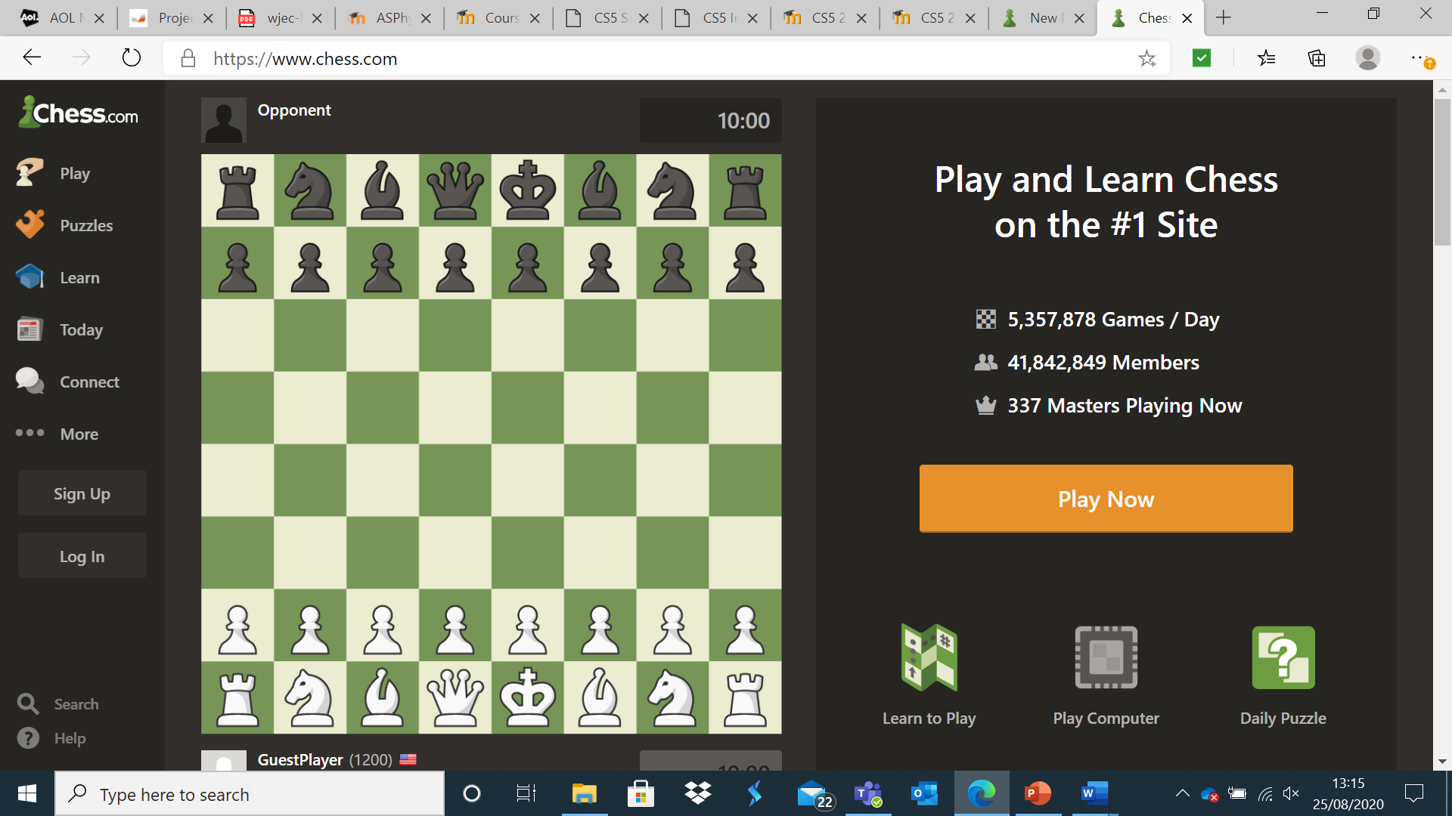

This is the home screen for chess.com and I can see why some users found it difficult to set up an account and play as the user interface is somewhat cluttered.

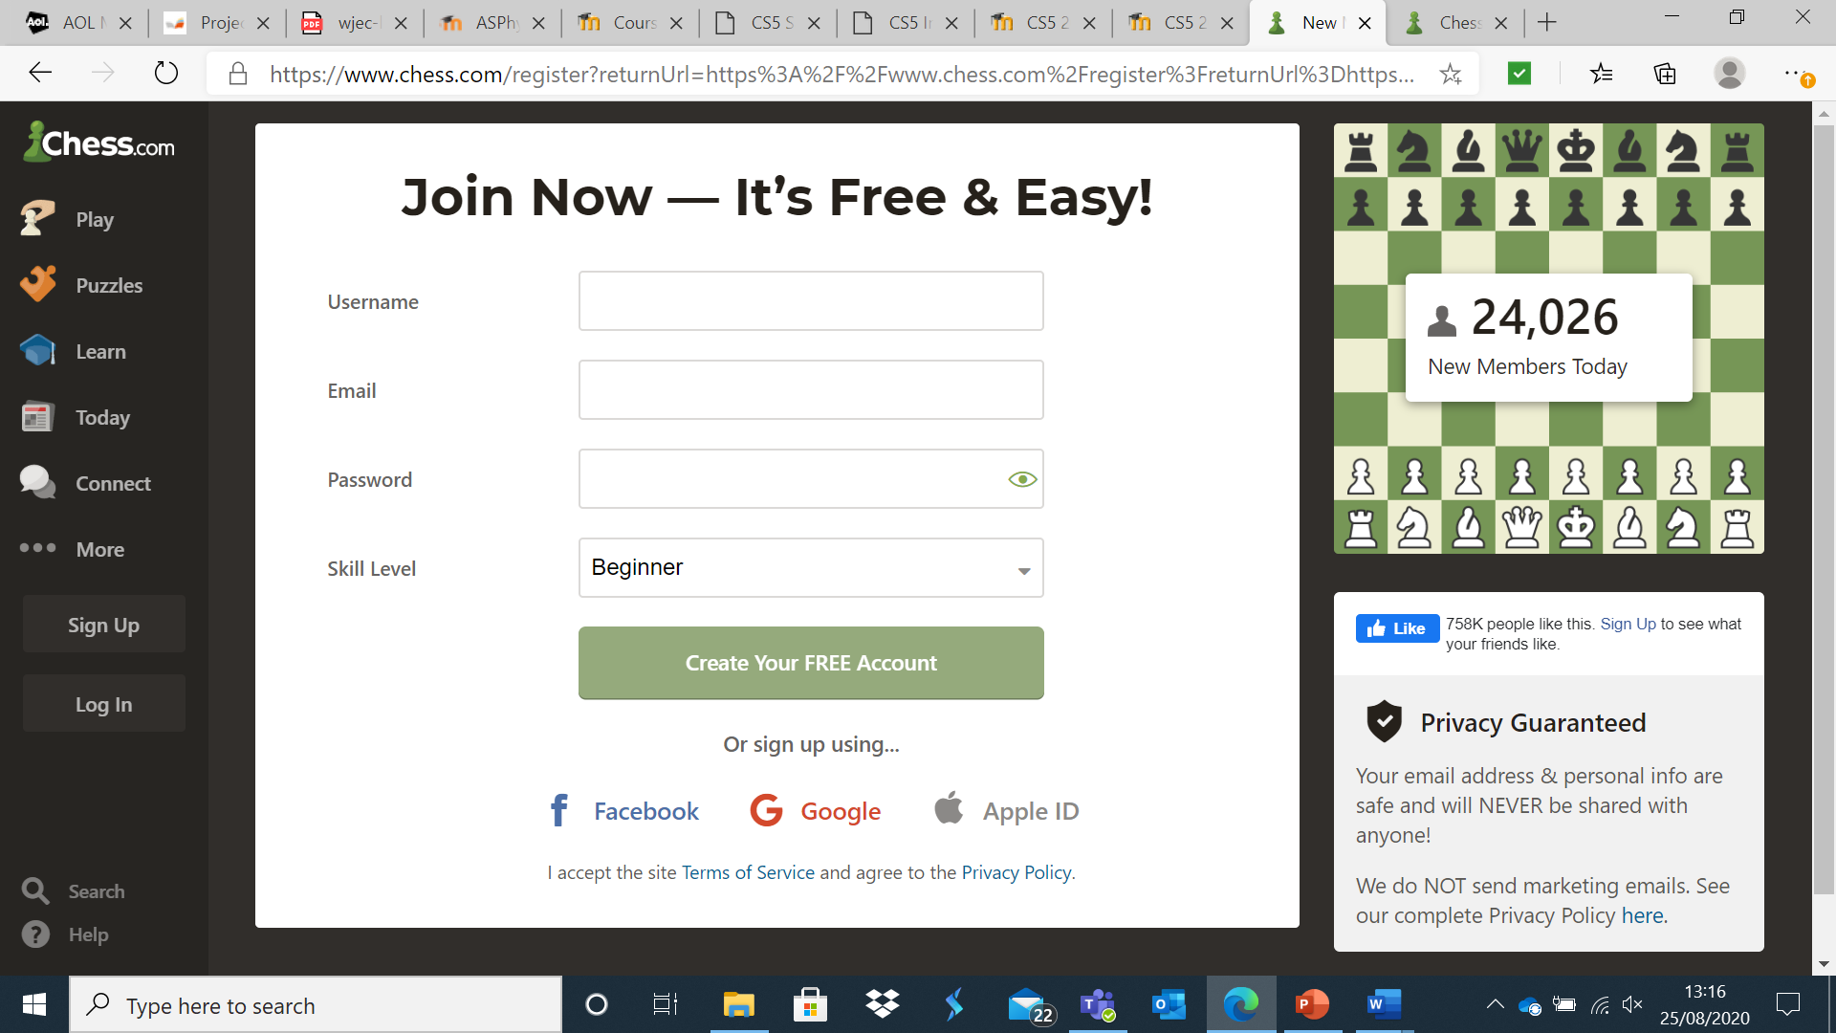

I then signed up for an account using my email address and creating a username and password.

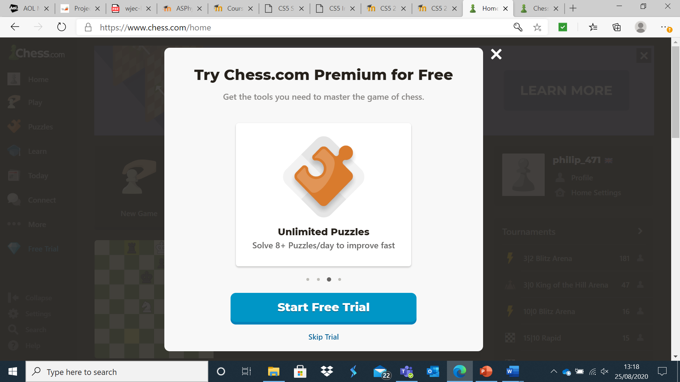

Upon setting up, I was asked if I would like a free trial of a premium service.

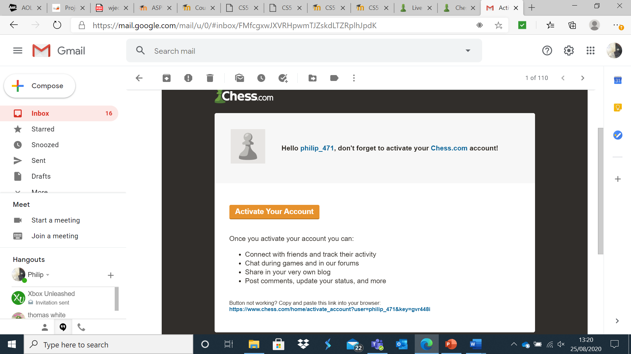

I was sent an email to activate my account, however I was able to access features such as online play without actually activating the account first.

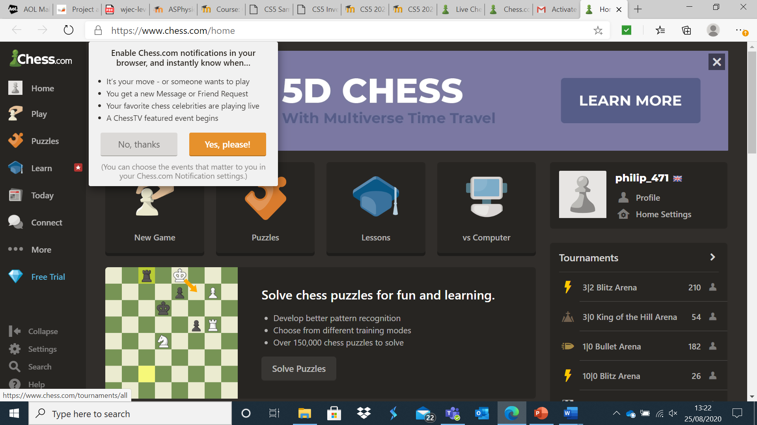

Upon activation, I was taken to the website and given the opportunity to enable notifications for my account.

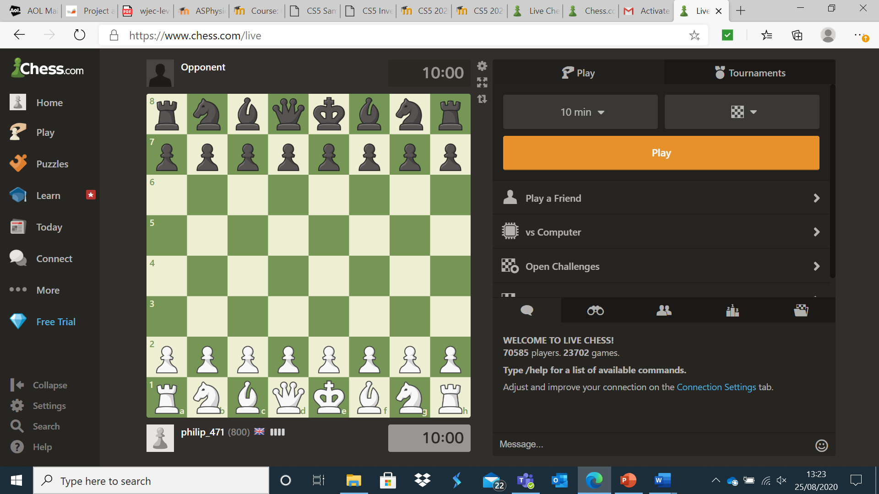

I then pressed the play tab where I had a range of options such as playing against the computer or against a friend or against a random opponent.

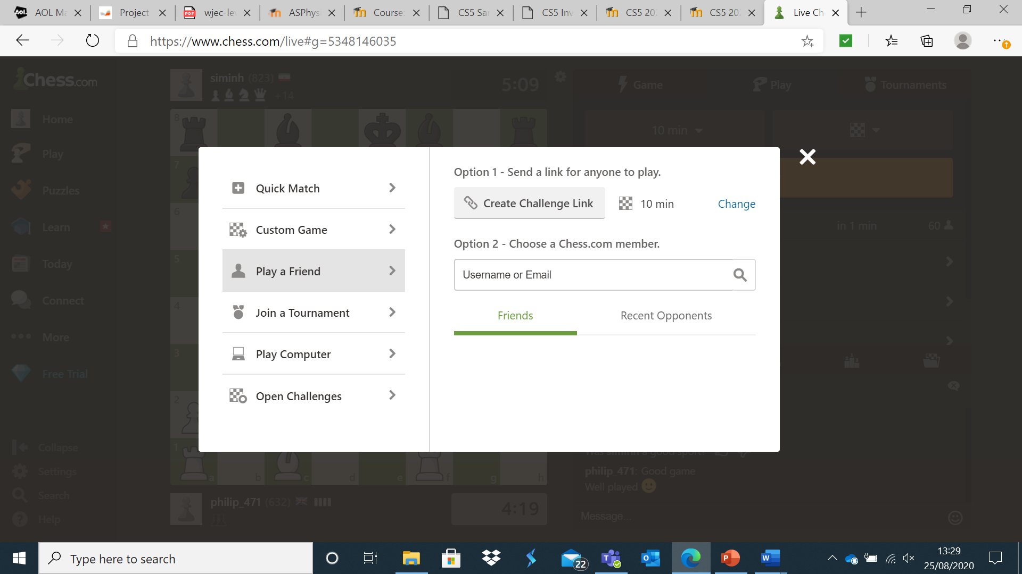

When one selects play a friend, one is given the option to invite a friend to a game via hyperlink or via email address / username. From what I understand, club members typically use the hyperlink option.

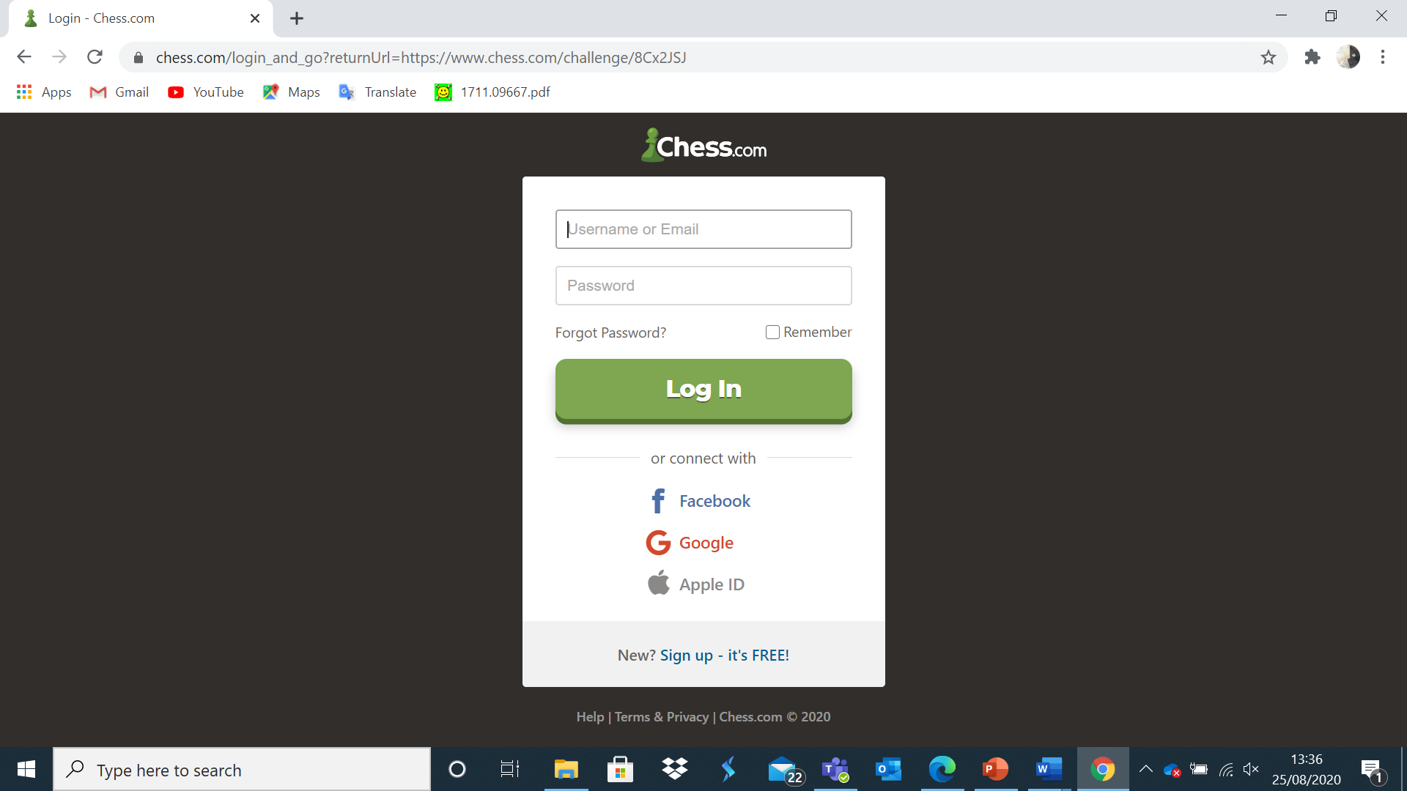

When opening the link, I had to log in in order to play against philip_471 (the user who sent the invite to my other account, philip_470).

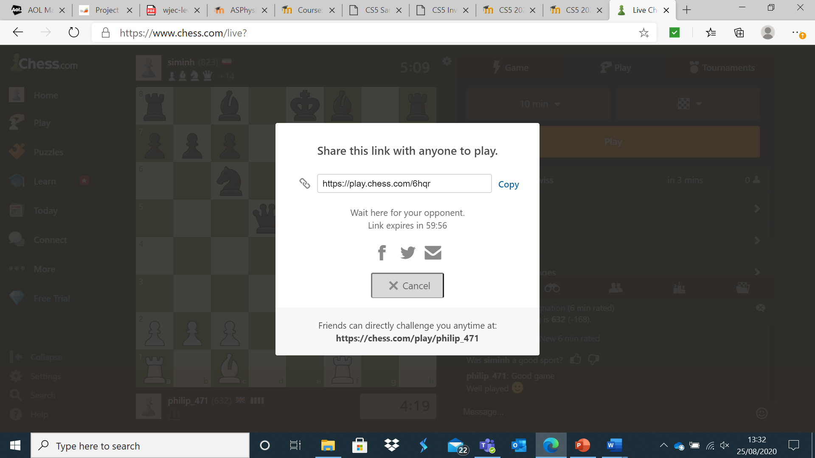

A link is then generated which a friend can click on to take them to a game against you. Note: I found this difficult to use as one has to stay on this screen for the link to remain valid (if close is pressed, the link becomes invalid).

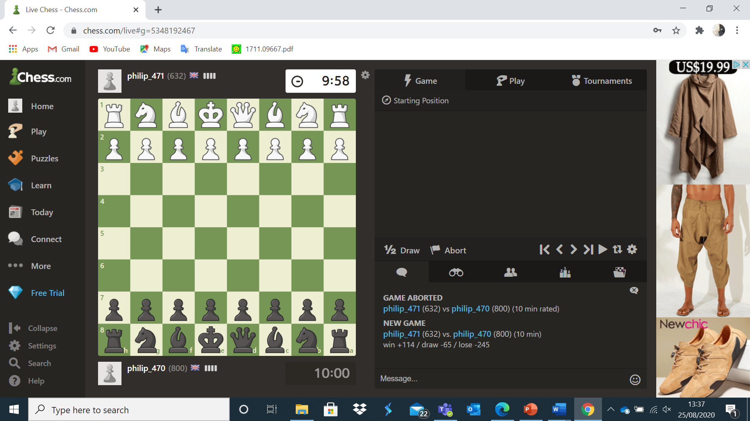

The game then commenced, and we played.

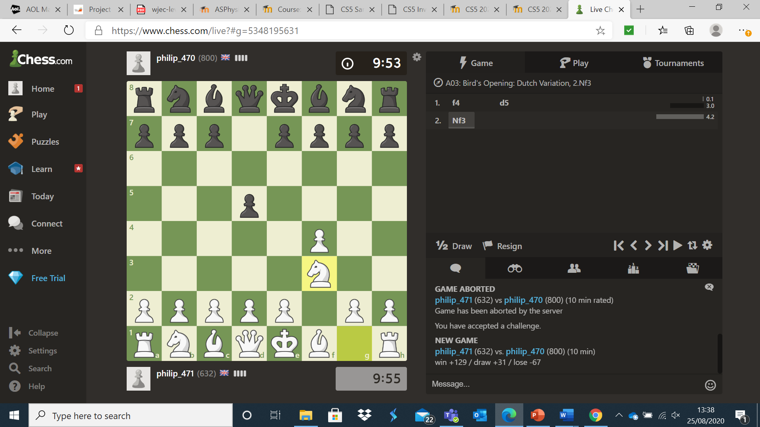

The user interface was excellent and making a move was intuitive and easy.

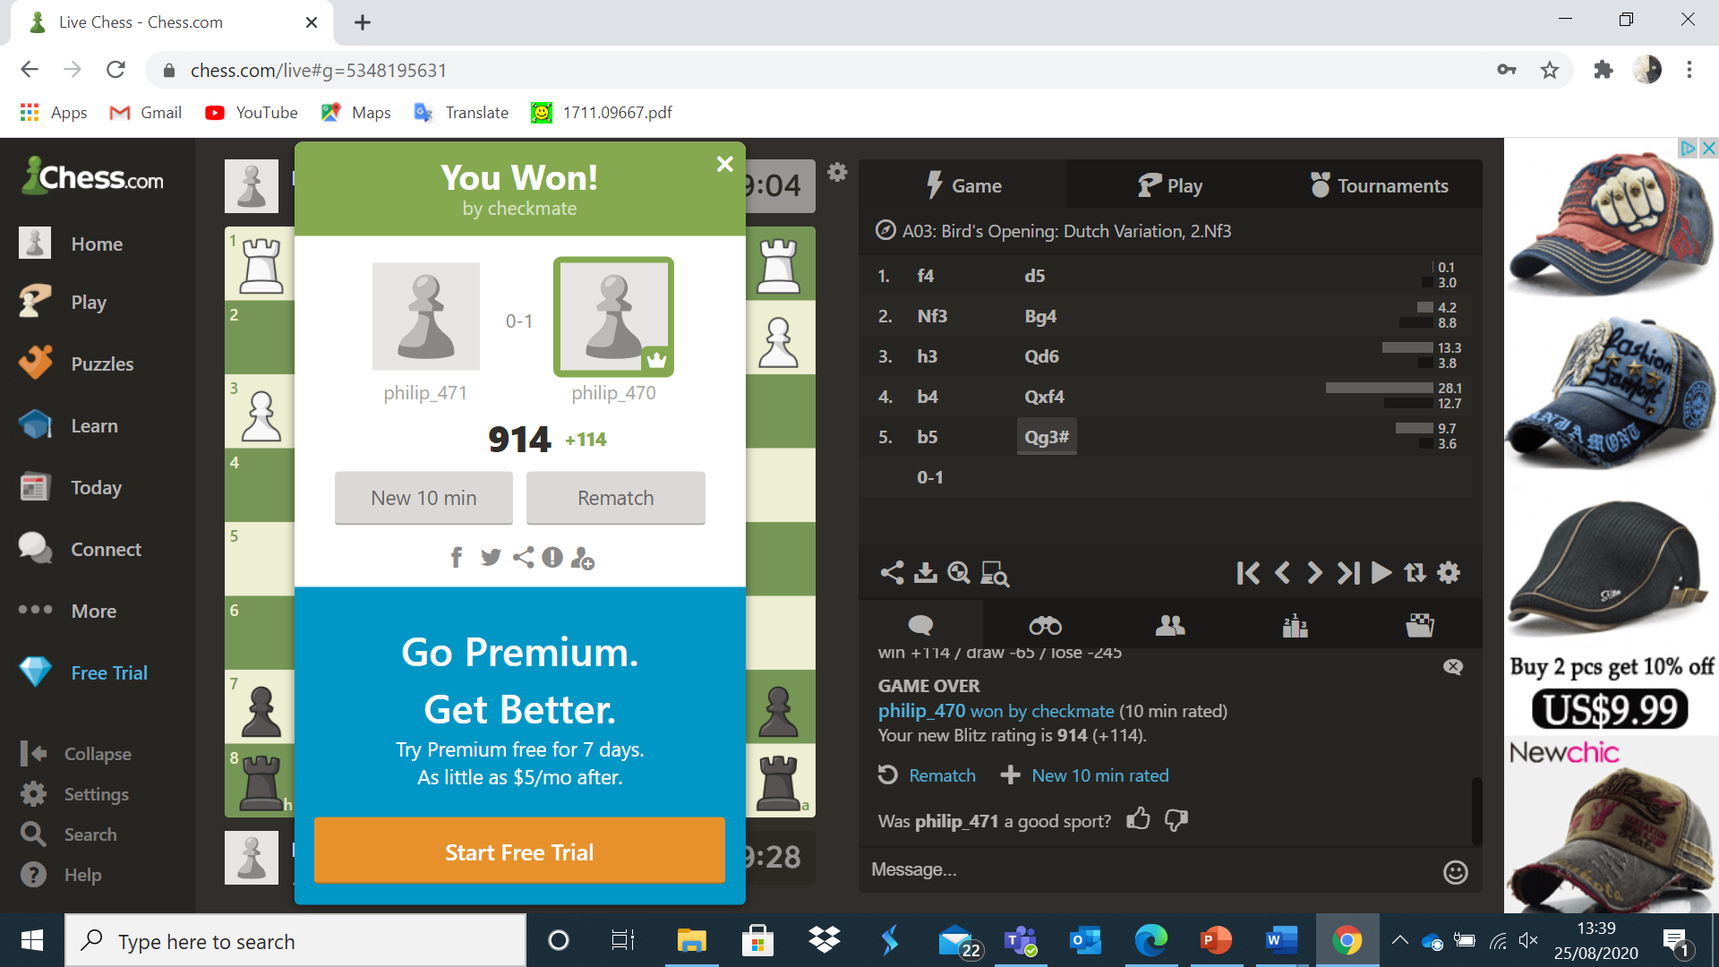

When a game is completed, an appropriate message is displayed to show who won the game.

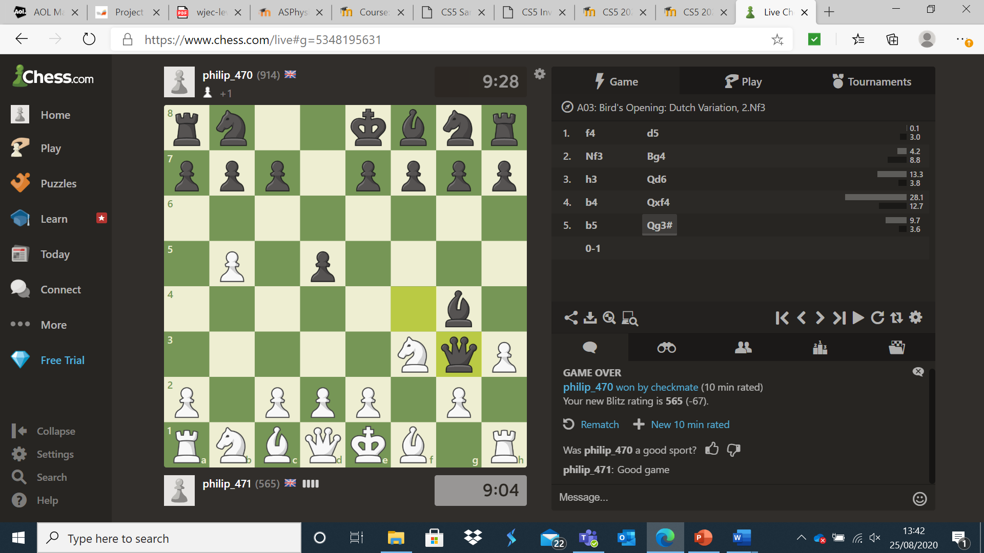

In order to play again, one has to click the play button near the top right of the screen, something which took me several attempts to discover.

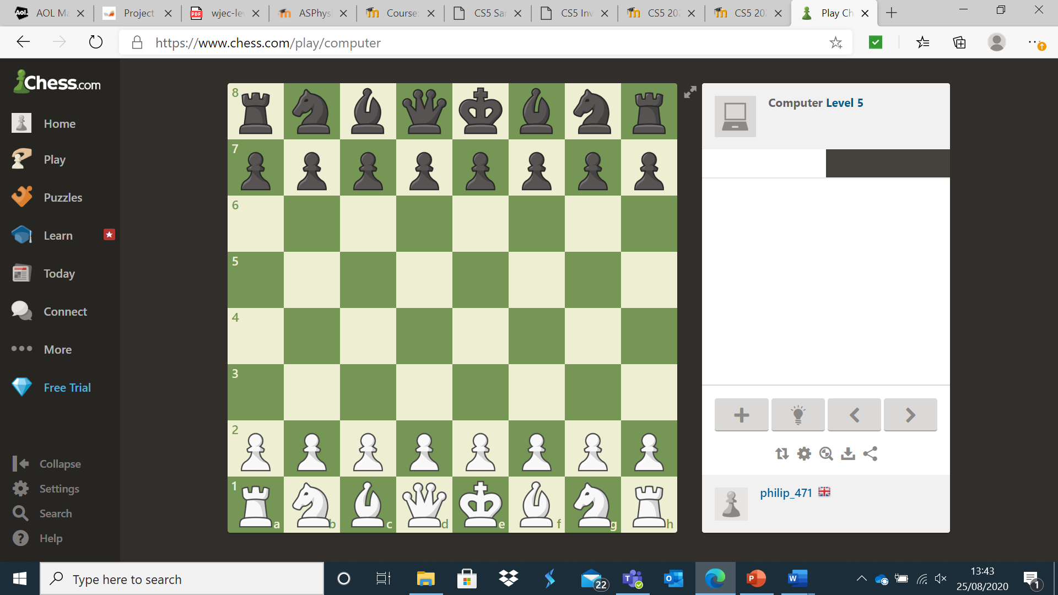

When making a move, one clicks on the piece one wants to move.

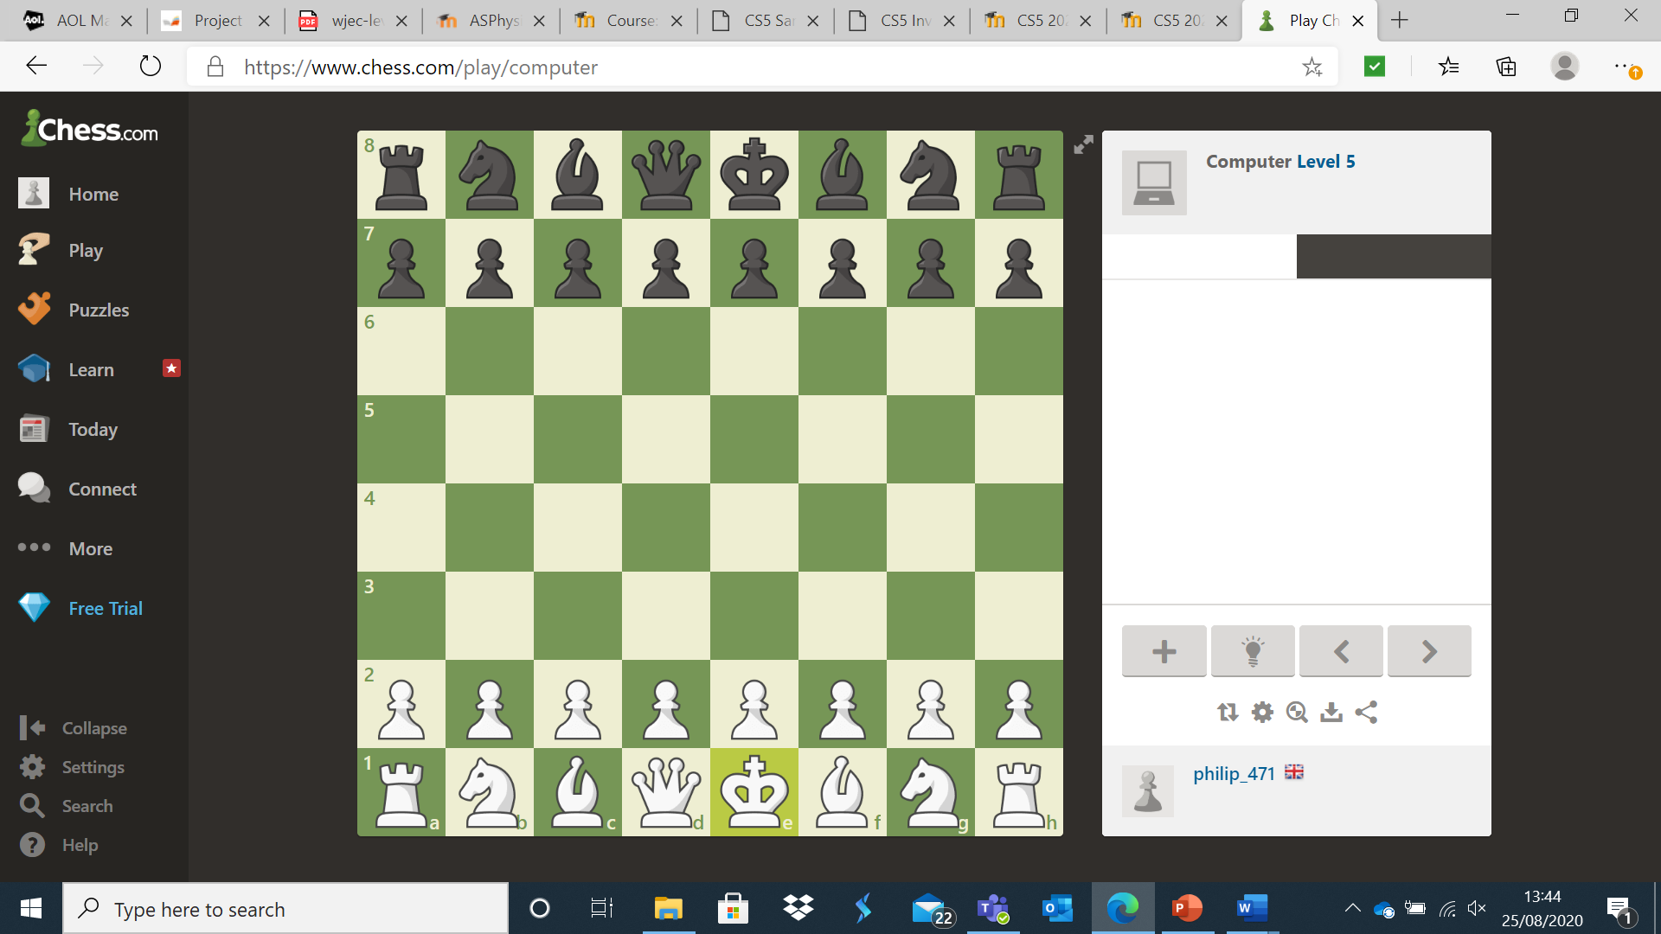

The piece is then highlighted, along with all available moves. As the white king has no available moves, no other squares were highlighted.

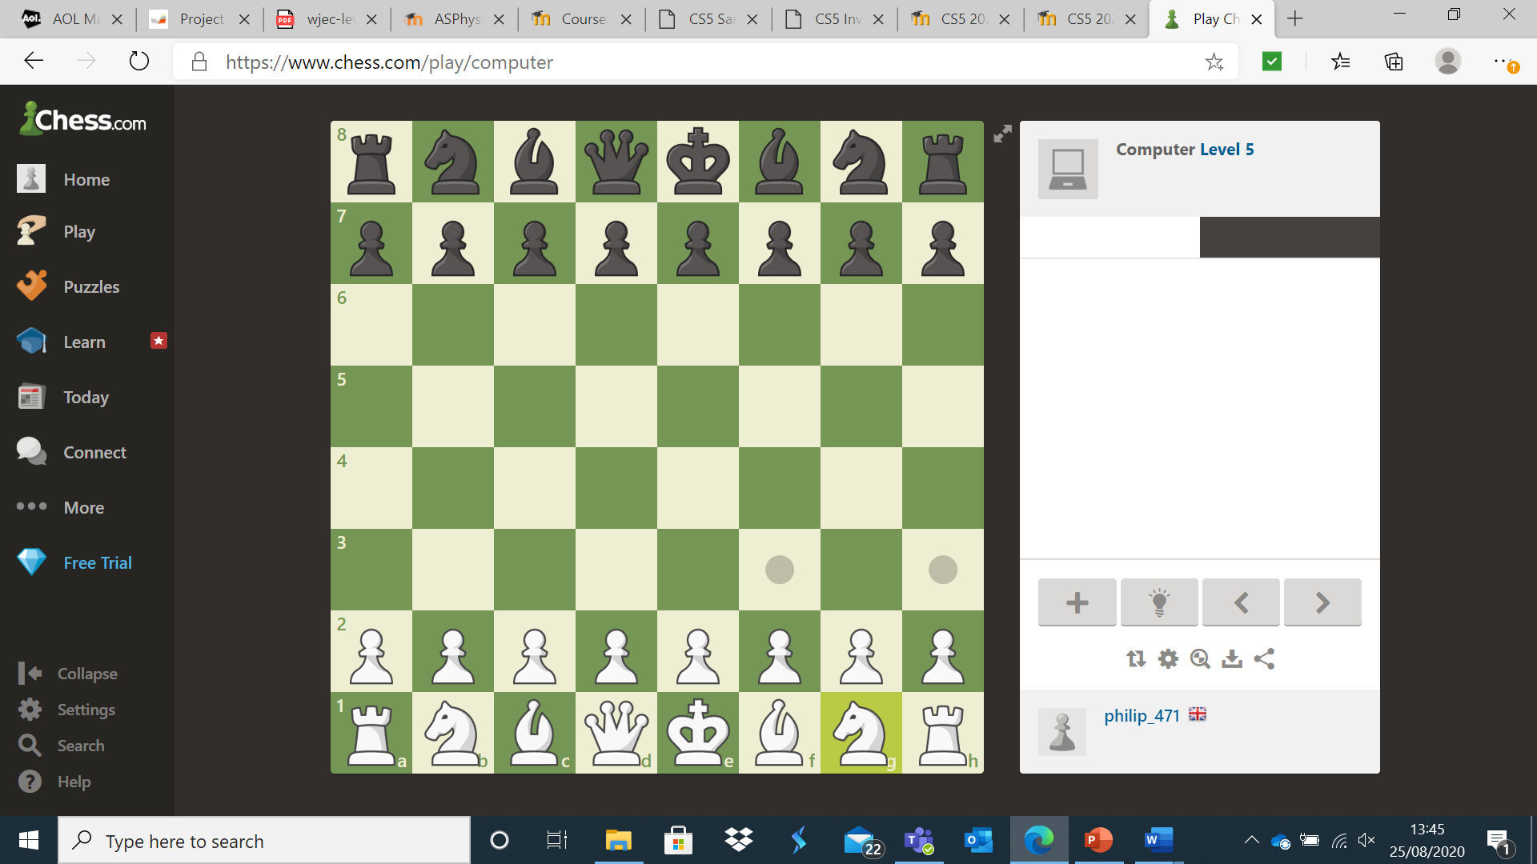

However, the white horse has two moves available and these are highlighted. One simply clicks on one of the squares available and the move is made.

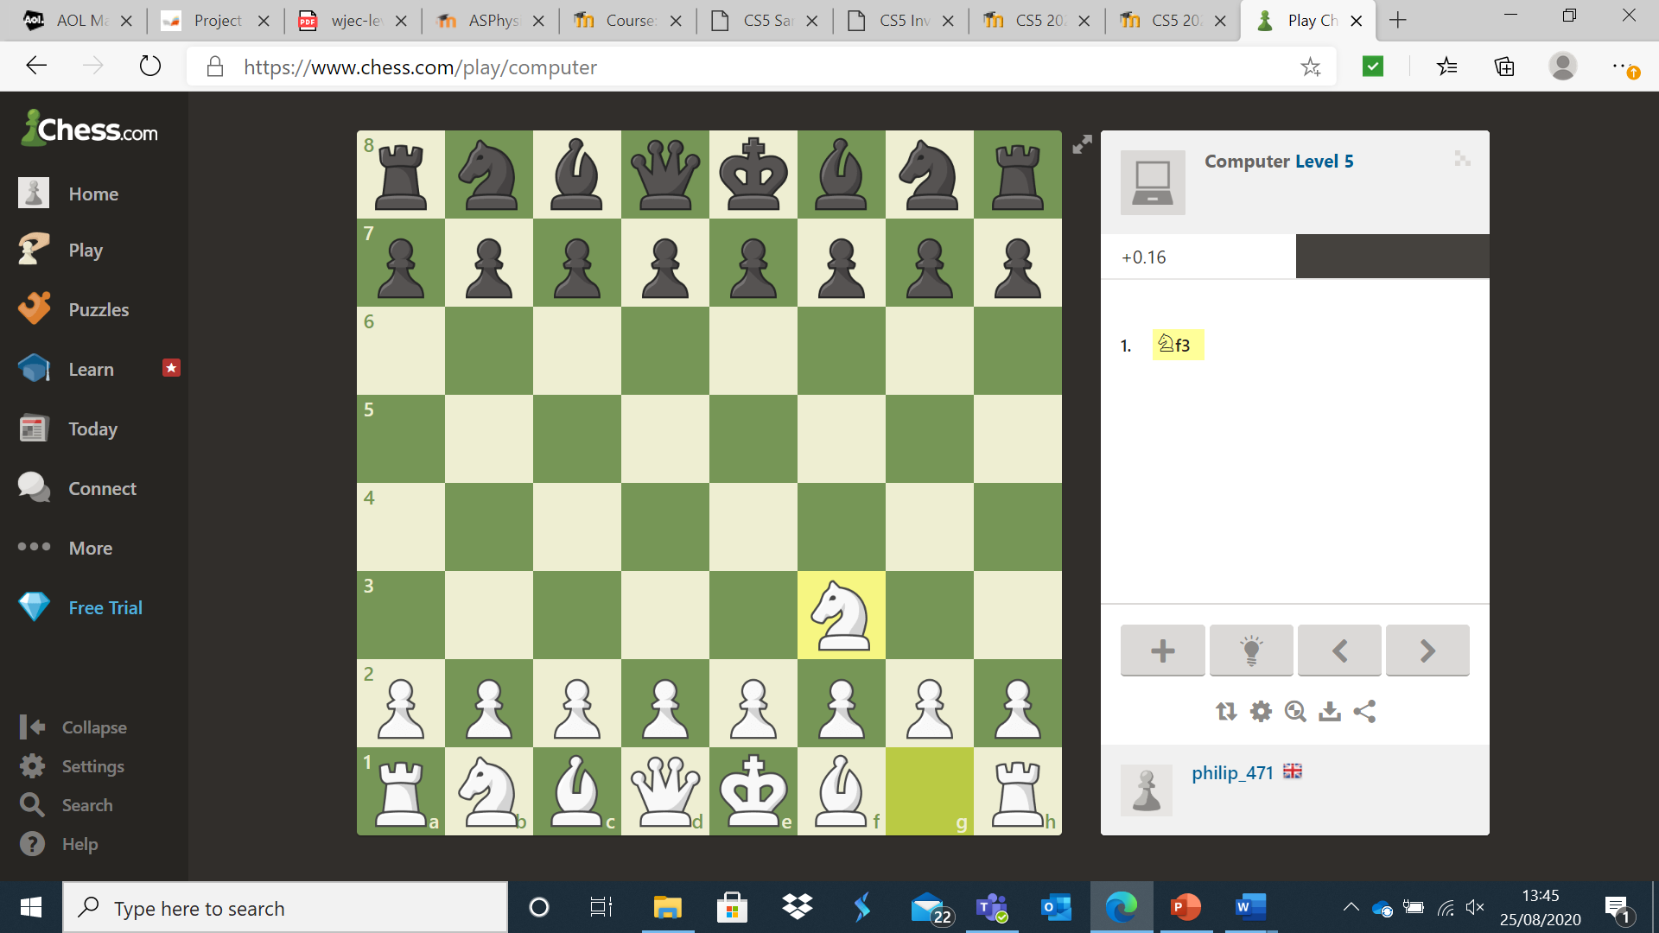

On the whole, I found the current system to be robust and was particularly impressed by how easy and fun to use the actual chess interface was. However, I encountered multiple problems with setting the game up (such as accidentally closing a section I needed to stay on or starting a new game once I had already completed a game). The use of Discord was much easier and more intuitive, however there was still a learning curve. Both Discord and chess.com are great pieces of software but have a learning curve, one that is presumably steeper for those who are not familiar with technology. Furthermore, both systems have a wide range of features that make them useful software but also lead to them being cluttered and overwhelming for users who only wish to use the software for specific purposes. From my observation, I took away that chess.com has a great user interface and control system. Therefore, I will include a similar click and move control system in my project. However, I found the navigation experience frustrating. Hence, I will aim to create a user interface that is clean and concise, making navigation far easier. Setting up and inviting a player to play a game of chess was ok once I had gotten used to it, but it was undeniably somewhat clunky. When this is considered alongside the numerous complaints from members about the scheduling and playing of club games, I conclude that there is a need for a much more intuitive scheduling system for club matches. Chess.com requires user details and navigation (i.e. what element of the system the user wants to access) as an input. Chess.com requires the piece a user wants to move as an input and outputs all possible moves for that piece (after having processed all possible moves for that piece). The user then selects one of these moves. This input is processed by Chess.com and the board is updated to show the move. When playing online, this leads to both user’s boards being updated. I anticipate similar inputs, outputs and processing in my system.

In order to fully investigate the system, I also looked at all existing documentation of the system. First, I looked at the matchmaking and league table system used by Lewis James. James essentially randomly generates fixtures so that everyone plays each other once. Then he duplicates this fixture list for the second half of the season. This means that everyone ends up playing each other twice. To update the league table, he uses a system where a win leads to three points, a draw to one and a loss to zero. If a user is unable to play a game, they forfeit the match. James and all members were kind enough to consent to me showing their full names. I have also censored personal details.

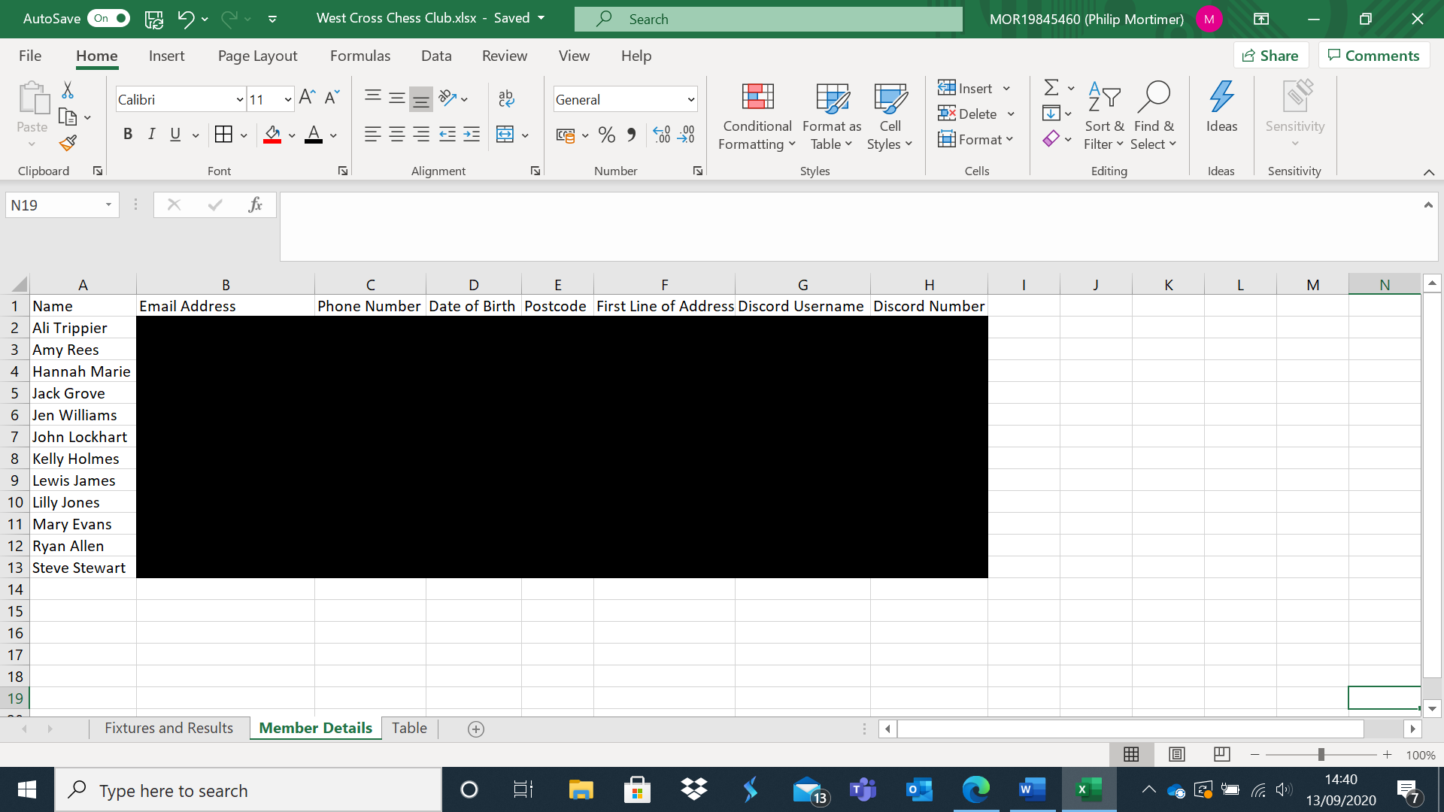  
Here are all the details currently stored. These details are stored to enable contact with members. The Discord details are stored to schedule games, phone number and email address are stored to contact the person and address, postcode and date of birth are stored for safeguarding and emergency reasons. Given all this, my system should store all of these details and give a way for the club leader to view the details. However, members should be aware that they are consenting to share these details with the club leader when they join the club.

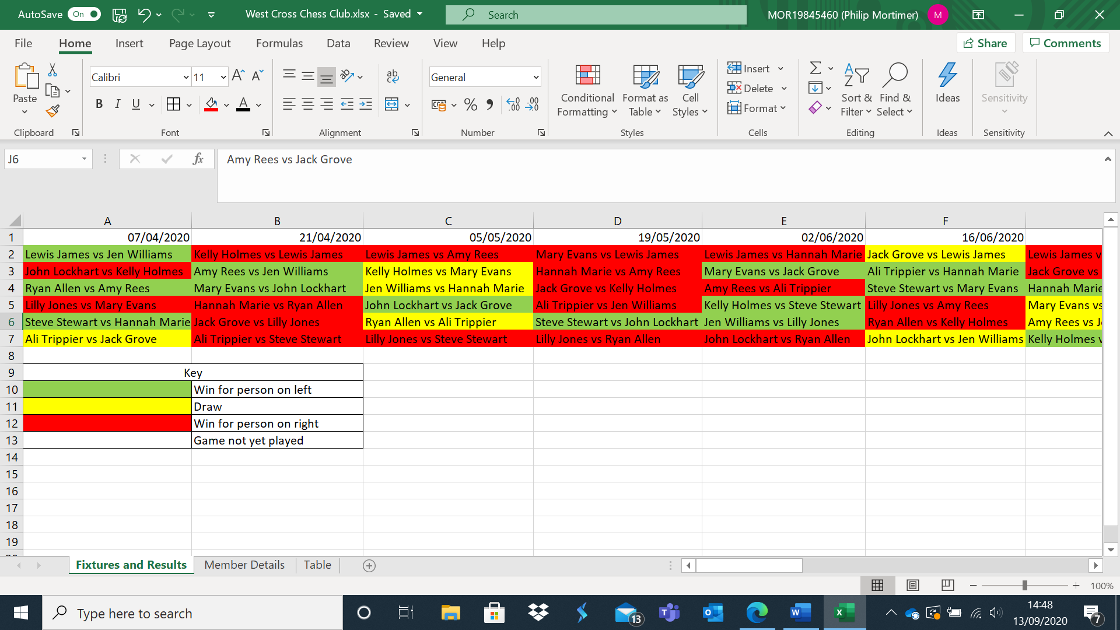

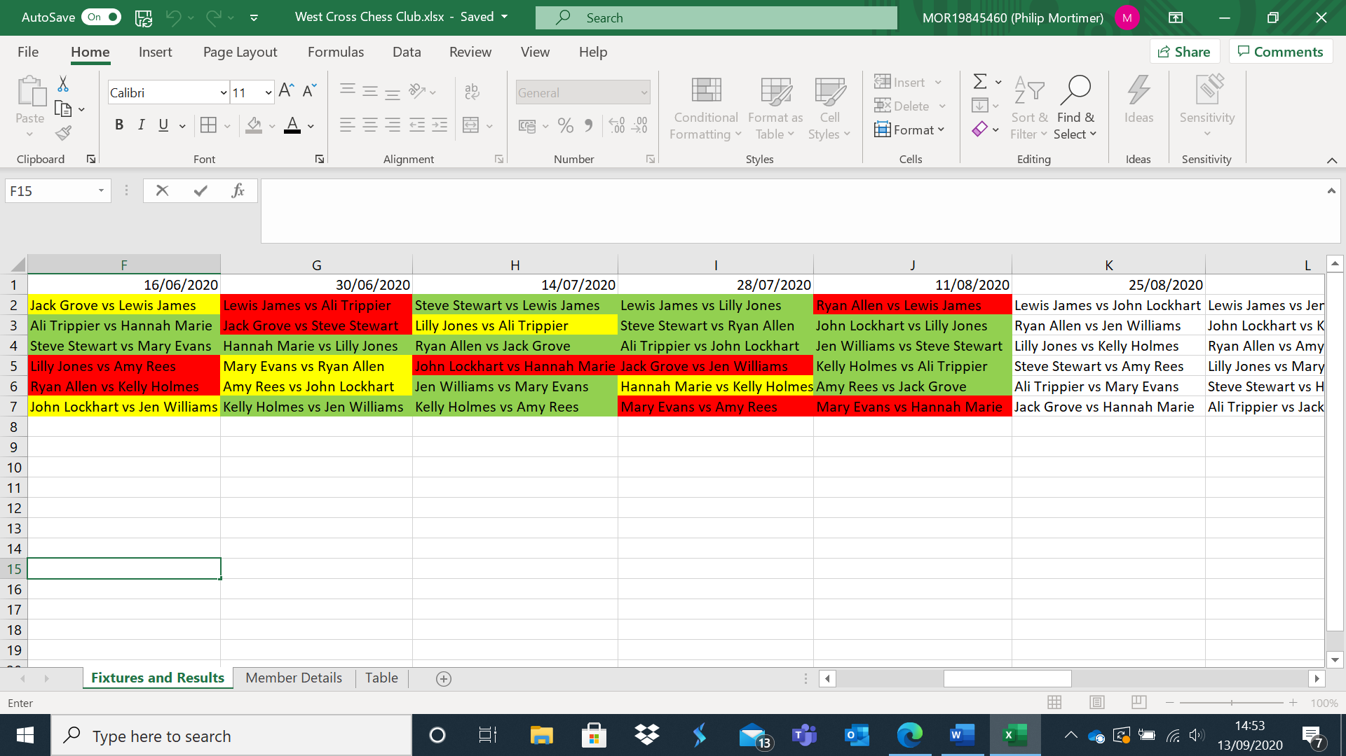

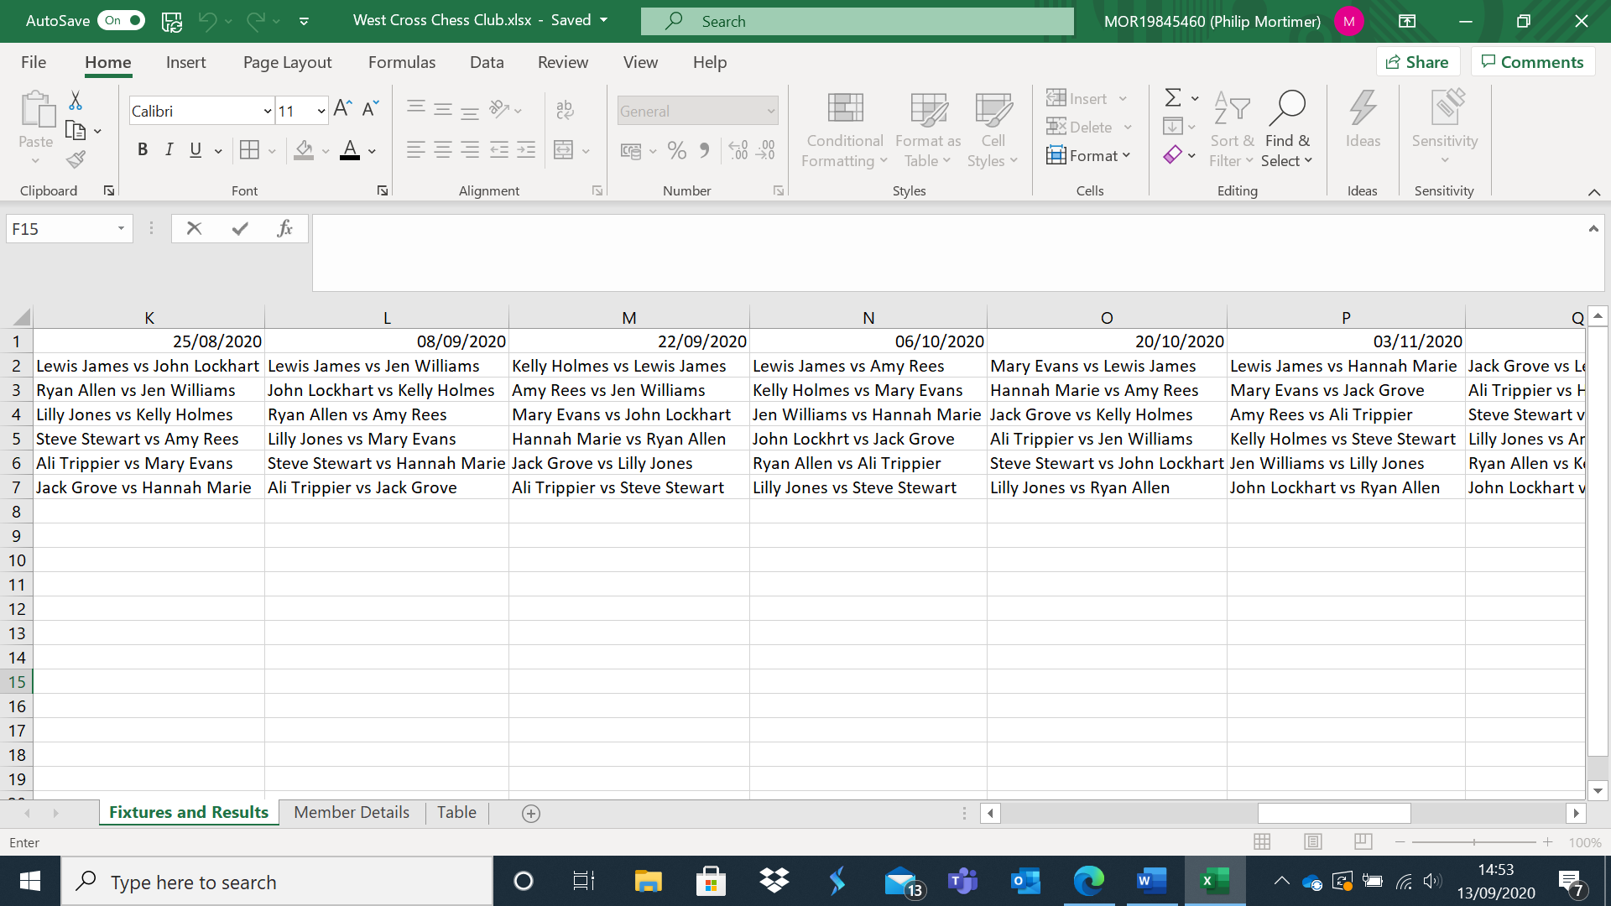

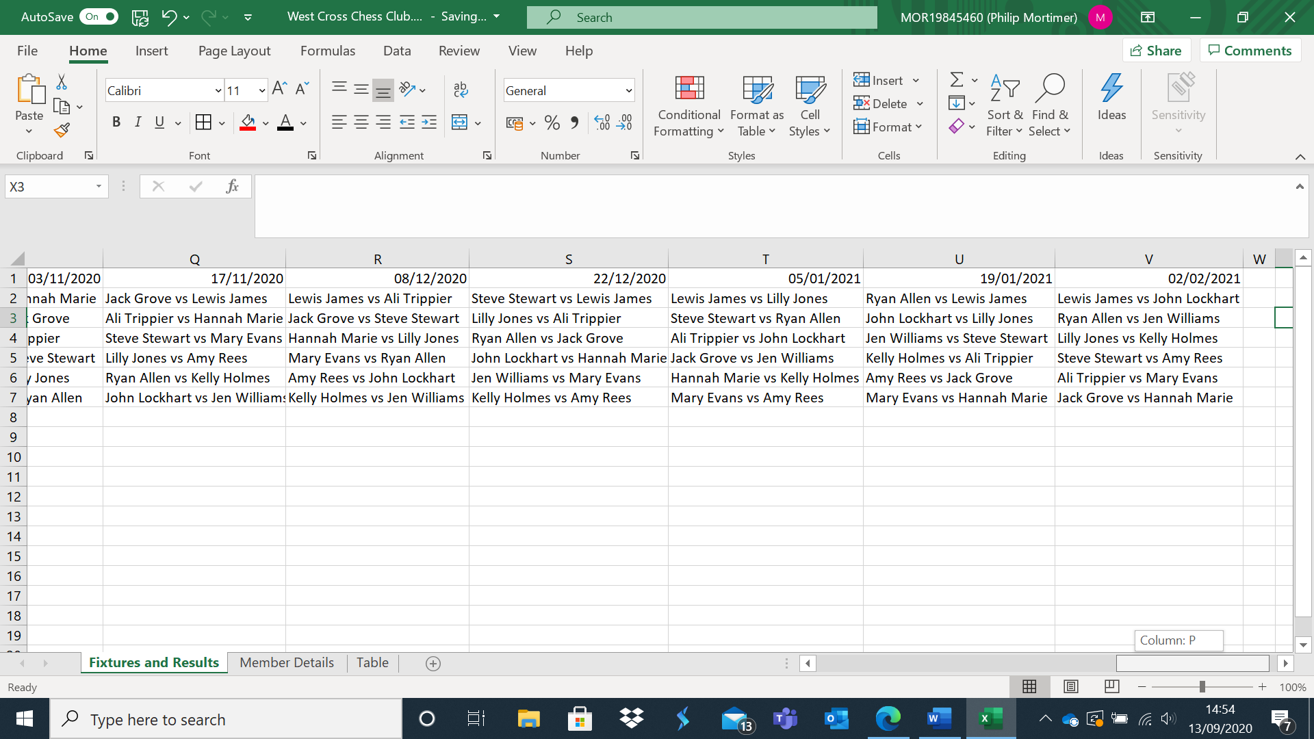

Here is the fixture list for the club. The fixture list is laid out so that each person plays every other person exactly twice. Wins for the left-hand name are represented with green columns. I found the system rather confusing as the colouring system for keeping track of game results is not very intuitive. I was also surprised at how long a single league lasts for. However, the method of match scheduling can clearly be enhanced by performing the work algorithmically. The new system would massively speed up this process as Lewis James clearly spends a lot of time producing and updating this sheet. I can also see why members would find it difficult to see upcoming fixtures as the document is functional but not very visually pleasing. This system would also be massively disrupted by somebody joining the club halfway through the season. If this occurred, Lewis James would have to spend more time scheduling fixtures for a newcomer. This could be automated, saving lots of time, and reducing the probability of an error being made. Furthermore, this could be displayed to members in a much clearer visual fashion, for example, by only showing them who they need to play next. My fixture generation system will need to take the names of all the members as inputs and generate the fixtures and then display these. If a member joins or leaves the club, the remaining fixtures and table will need to be updated to reflect this.

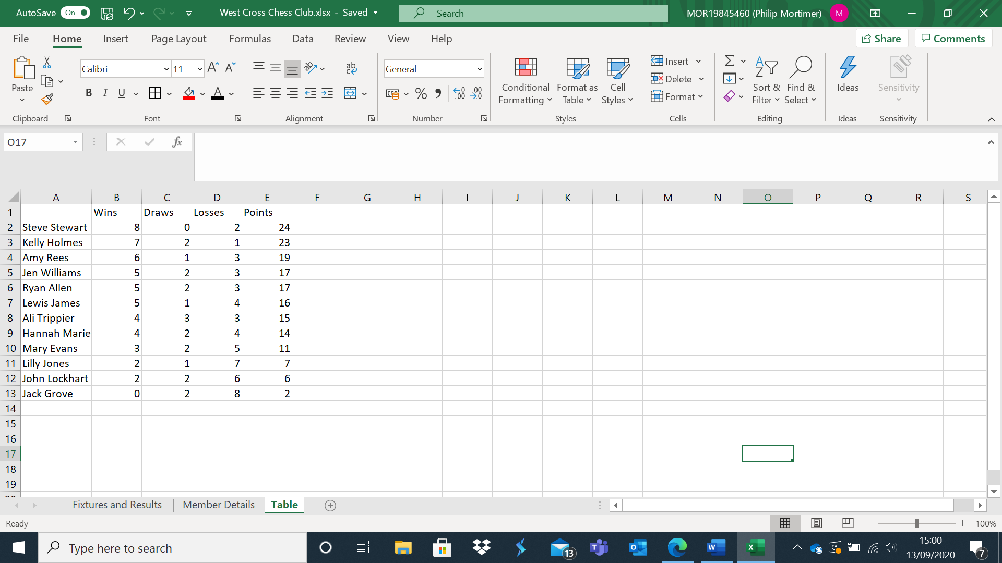

This is the league table. The table is laid out in a pretty standard fashion. A win is worth three points, a draw is worth one point and a loss is worth no points. To implement this in my system, I will probably use a JTable (a Java GUI element) to store and display the table. The system will have to collect results to process the new table and update it.

I also looked into the ruleset the West Cross Chess Club used. Lewis James said they used the standard chess ruleset, which is well documented. I read up on these details at the following links: <https://www.chesscentral.com/pages/first-moves-in-chess/the-rules-of-chess.html> <https://en.wikipedia.org/wiki/Rules_of_chess>

<https://chess-teacher.com/chess-rules/#:~:text=THE%20RULES%20OF%20CHESS%201%20Nature%20and%20objectives,chess%20pieces.%20A%20bishop%20moves%20any%20number%20>

The rules of chess were the same across all these websites and align with common knowledge. I did learn about some special types of moves such as en passant and castling, which I will need to consider when implementing my game as these moves have more complicated rules. I will need to store variables such as whether a castle has made its first move yet in order to implement these features. In fact, the only rule of chess that varies is the timer control. As Lewis James correctly points out, the FIDE method is often used (90 minutes for the first 40 moves followed by 30 minutes for the remaining moves. Thirty seconds is also added to the timer after every move). However, sites and people use a great range of timings. Most of the time, these timings are not very relevant as most amateur players do not come anywhere near the time limit. However, it does show me that my system will clearly need multiple timer options and some form of timer displaying to show users how long they have left to move.

As I am also planning to create a computer opponent of multiple difficulty settings, I looked into methods to program a chess AI. Most chess systems use an alpha-beta pruned minimax algorithm to determine the move the computer should make. This algorithm looks at every possible move from a given board state and every possible move from each of those resulting states and so on until it looks at every single possible board state. This technique has been applied to games such as noughts and crosses to achieve perfect play. As chess is a complex game, it is computationally infeasible to look at every possible state and hence most algorithms have a depth limit. For example, a computer may only look two moves into the future. When it reaches these nodes, the computer has to score the value of the board state in a given way. If the board state results in a loss, it may be given a score of -1, whilst draws are scored at 0 and wins scored as 1. However, if the result of the game is not known, heuristics may be applied to estimate the value of the board. There are heuristics of varying degrees of complexity. One common heuristic is adding up the number of pieces each user has and multiplying them by multipliers (e.g. a queen may have a value of nine whilst a pawn may only be deemed to have a value of 1). By using varyingly advanced heuristics in combination with varying search depths and also random errors, one may program chess systems of varying difficulty. I plan to use the minimax algorithm in my project and create computers opponents of differing difficulty levels by using different heuristics, search depths and probabilities of the computer making an error when executing the algorithm. I have yet to decide on which heuristics I will use, however I would like to have computer opponents that have at least 5 difficulty settings. I am considering using a method similar to the one described in “DeepChess: End-to-End Deep Neural Network for Automatic Learning in Chess” by David, Netanyahu and Wolf. This system uses an artificial neural network to evaluate board states and achieves grandmaster level of play. However, I lack the computing power to train a neural network on as many training items as they do, which may lead to it being infeasible to implement. Furthermore, a neural network may also be too memory and processing intensive to use in conjunction with a minimax algorithm for many computer systems. Therefore, I shall attempt to implement the feature, however I may scrap it in favour of a less resource intensive heuristic.

Finally, I observed a game night for the club to verify my understanding. The experience was exactly the same as when I used chess.com and the exact same procedure was followed. The only difference was that fixtures were accessed through the West Cross Chess Club Discord Server. One member then generated a hyperlink and sent it to the other member to play. Some used Discord’s voice chat to play with each other and talk. Discord’s voice chat functioned flawlessly and was very enjoyable. Therefore, I think it is a good idea to allow users to continue to use Discord to talk to each other if they so choose.

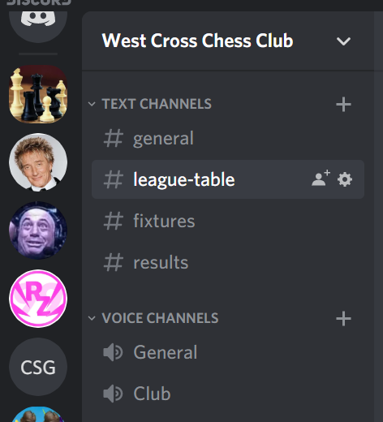

(Note I have added a black box to hide other Discord servers that I am part of as they are not relevant and lead to a more confusing image).

Research into Existing Solutions

Arguably the most notable system currently is chess.com, the software used. However, there are other systems out there. The first system I looked at in any detail was the one used by De La Beche chess club (another local club). Here is my exchange with one of the members of the club, Ken Huntley:

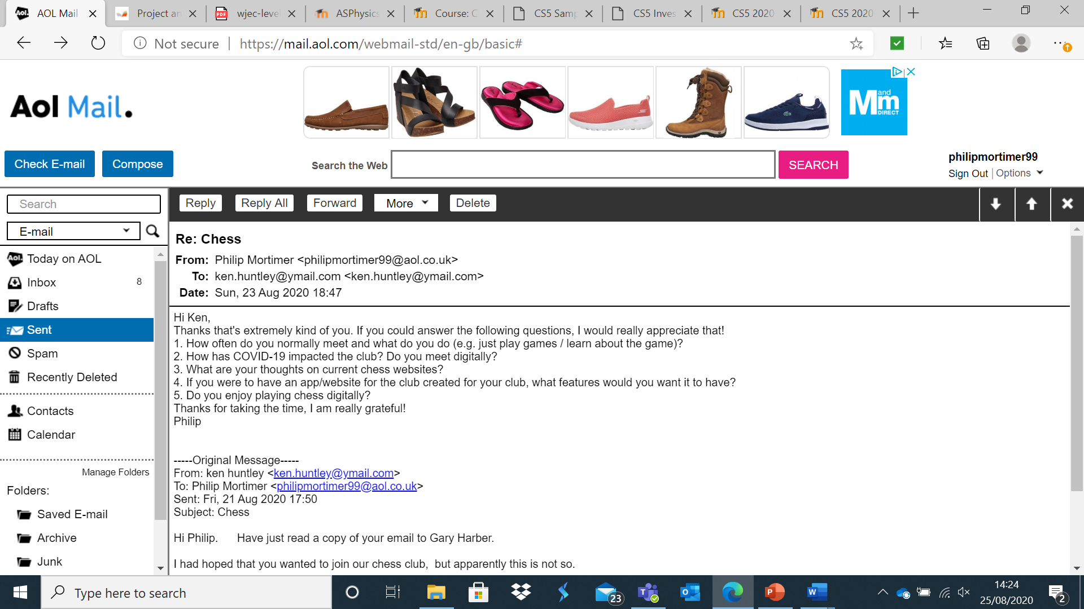

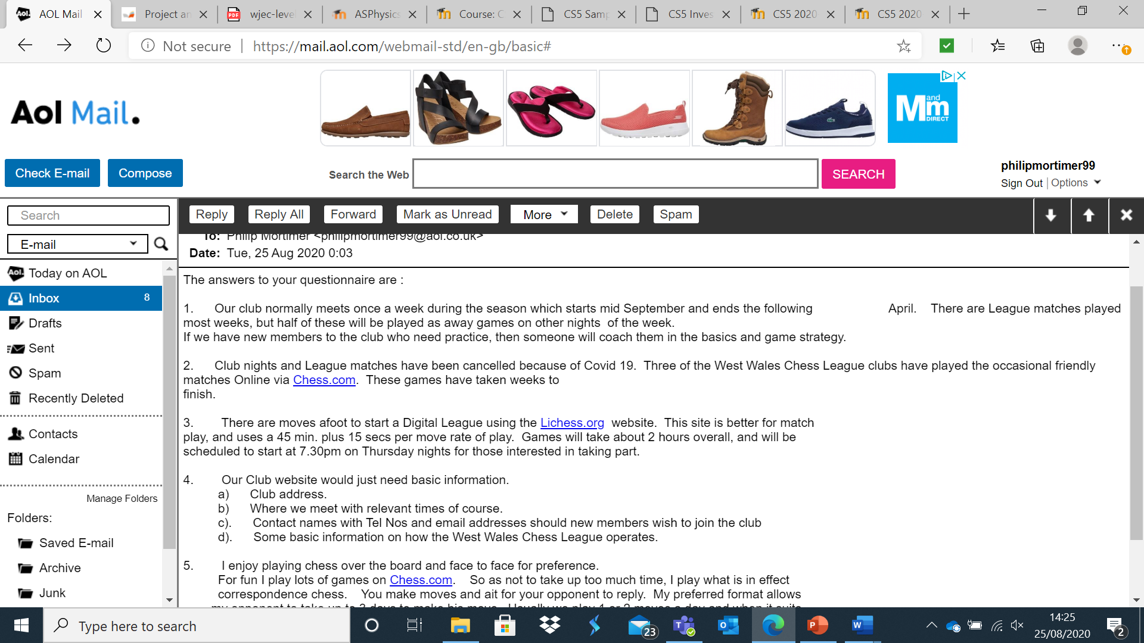

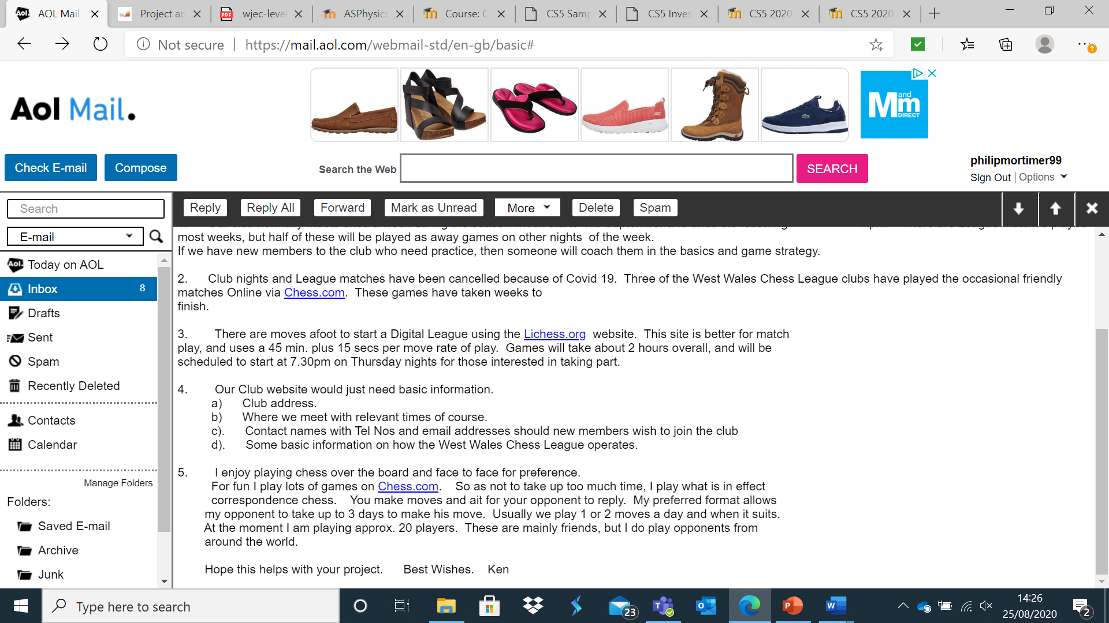

Ken talks about the occasional use of Chess.com for friendlies ,however he highlights that games often take far too long to complete on the site. He enjoys the ability to play chess more leisurely using correspondence chess, which allows one to play many games of chess over a long period of time. This is a feature that I would like to include in my application as I think it is an important feature, particularly for casual play.

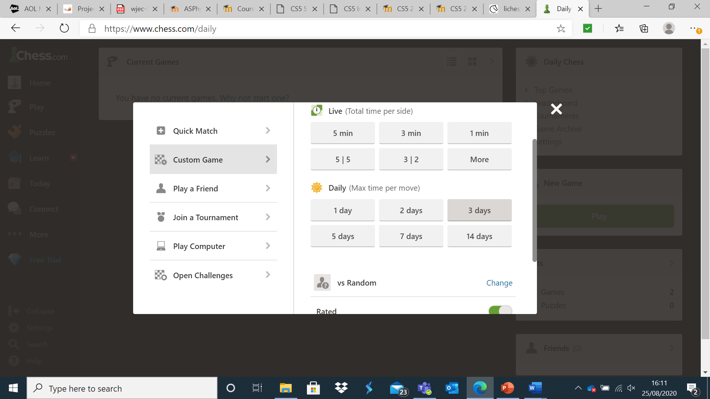

Here is an example of Chess.com’s option for correspondence chess. The site allows you to specify the maximum time per move, with 14 days being the upper limit. Whilst this is a sensible feature, I would probably remove this feature and simply have both sides play until a terminal state has been reached.

Ken talks about lichess.org, chess.com’s biggest competitor and a system that I will also look into. Ken however seems to think that the current digital system is not suitable for the club although he seems open to the idea of using lichess.org as part of a digital league.

Lichess.org is another chess system that is frequently mentioned and one that I shall analyse.

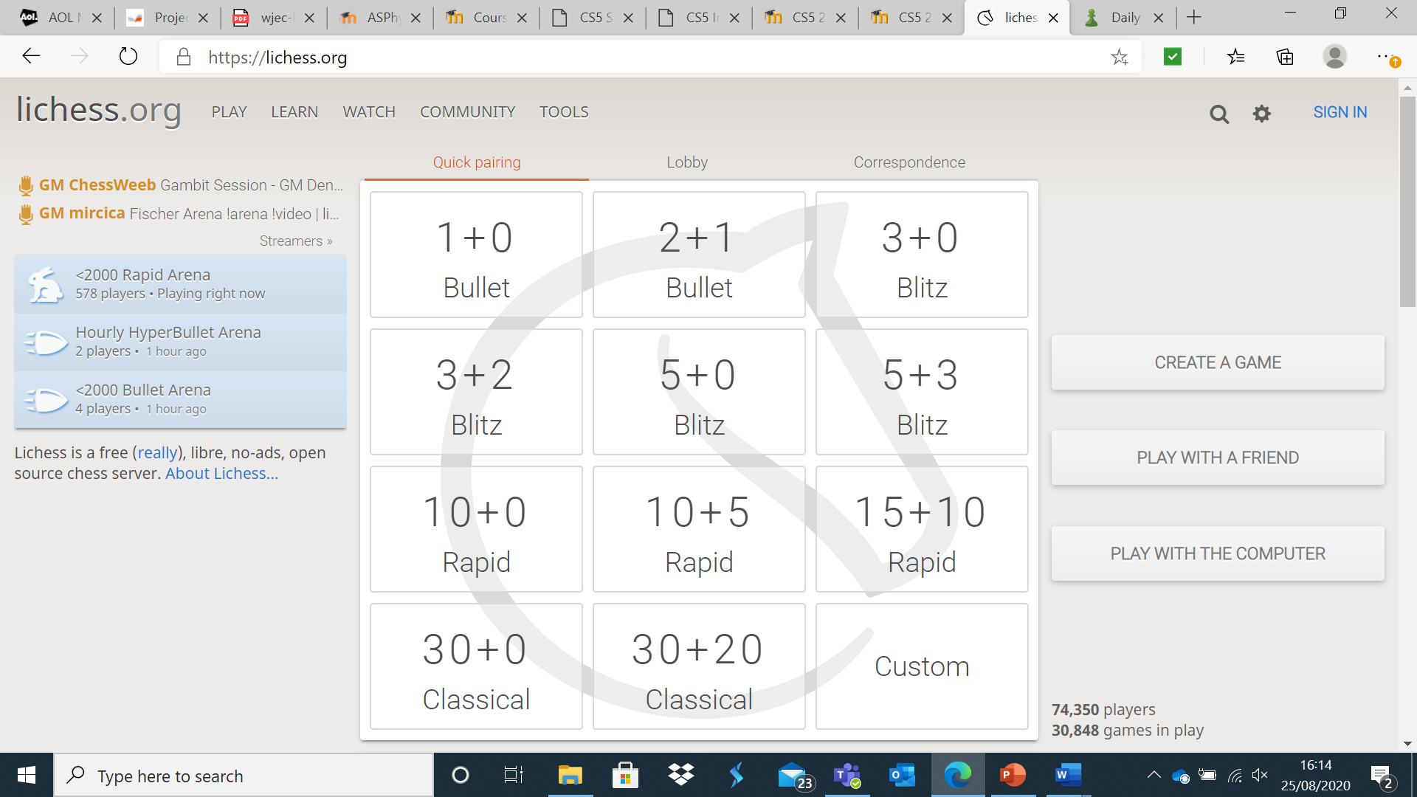

Lichess features a much cleaner home page in my view that allows one to easily navigate to the most important sections more easily. In my system, I will have buttons of large size similar to lichess.org that allow “PLAY WITH A FRIEND” and “PLAY WITH THE COMPUTER” although I still think the display of lichess.org is not entirely beginner friendly due to the large number of buttons displaying rule options that most rookies will not be familiar with. However, it is a good balance as the beginner friendly buttons are large and to the right, with the more advanced options also being easily accessible.

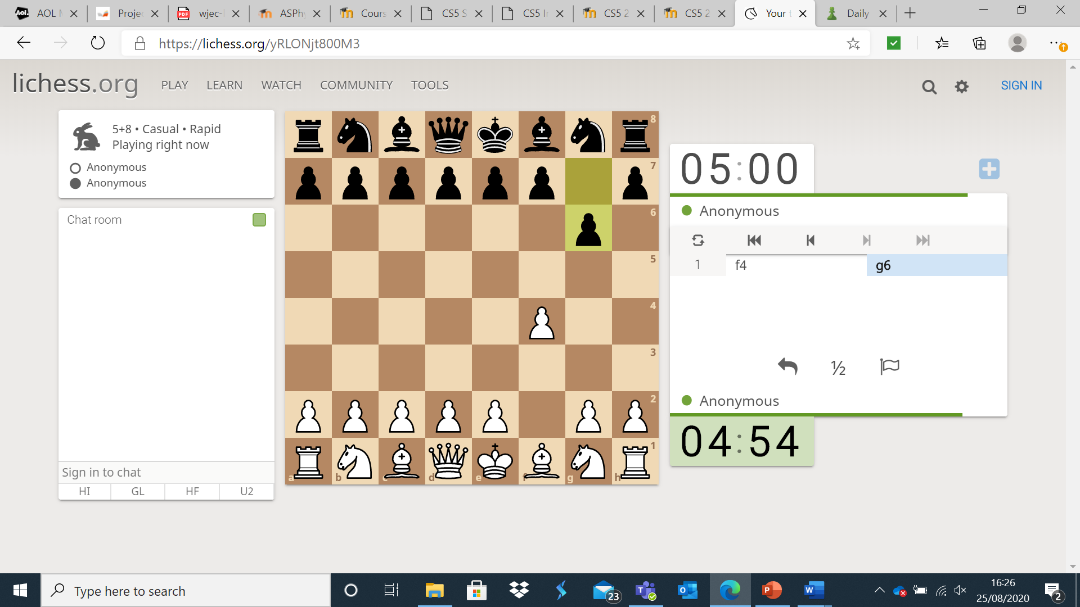

I am a particular fan of the fact that Lichess allows one to play as an anonymous person (i.e. a guest) who does not have an account. I think that this feature is particularly useful for those who may struggle with technology (something which my questionnaire showed to be true of some members of the West Cross Chess Club) and would be a good way to allow them to easily and quickly play chess. The chess board is similar to that of chess.com, with one clicking on a piece to select it and then dragging / clicking it to a legal square. I while implement a control system similar to this as it is easy, satisfying, and intuitive. I was also impressed by both chess.com and Lichess’ function that allows one to see the previous board state. This was very useful when I had looked away from the board to find that my opponent had made a move.

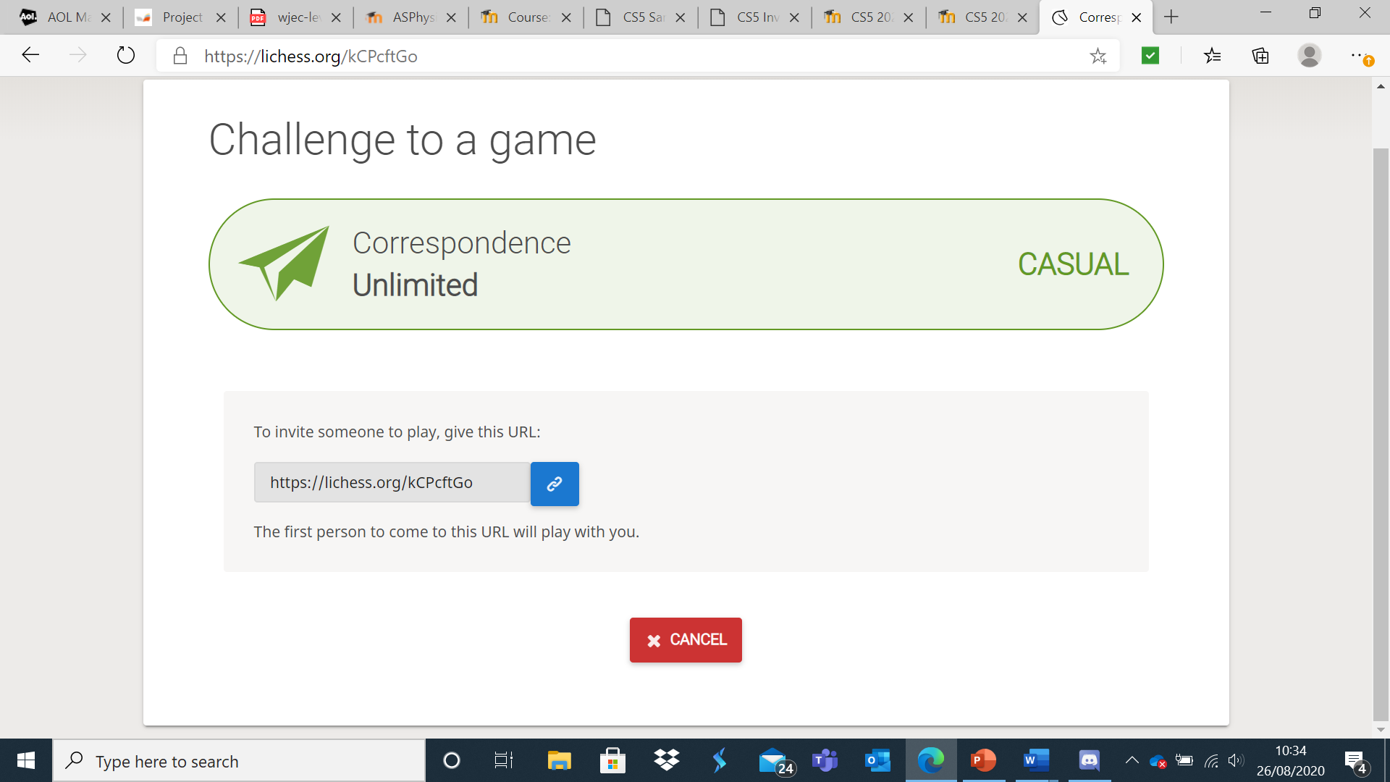

To play against a friend, Lichess generates hyperlinks. As I am creating a Java project, hyperlinks will not work. However, to emulate this I will generate a random 6-digit code that will allow friends to play against each other. Similar to chess.com, I will also give users the opportunity to invite each other through their username / email address. I would use the code as it would allow people to play against each other without having to log-in (something which less technologically confident users would appreciate).

I also took a look at some chess games one can install via the Microsoft store as these will match my project more closely than a website.

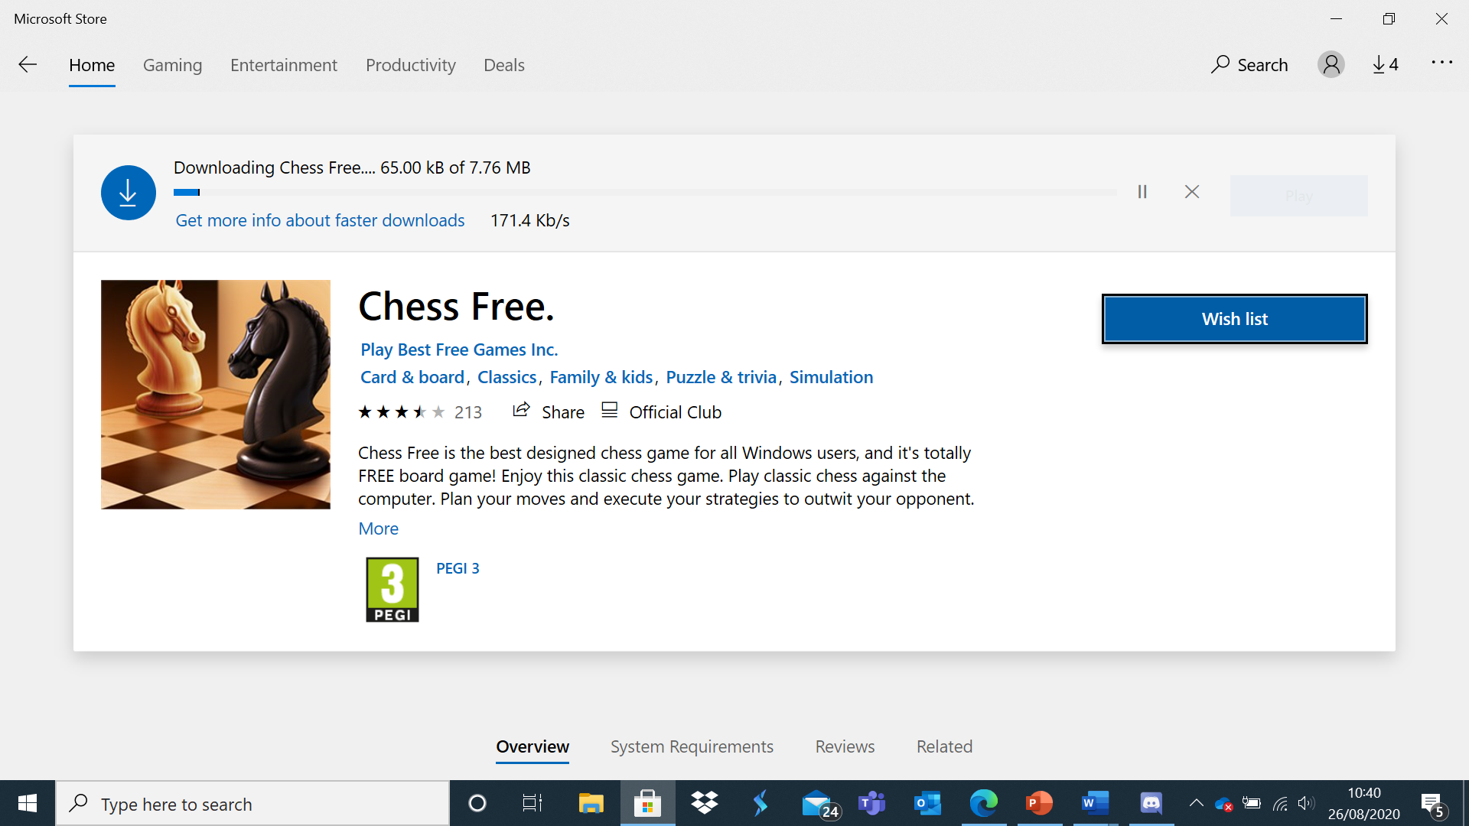

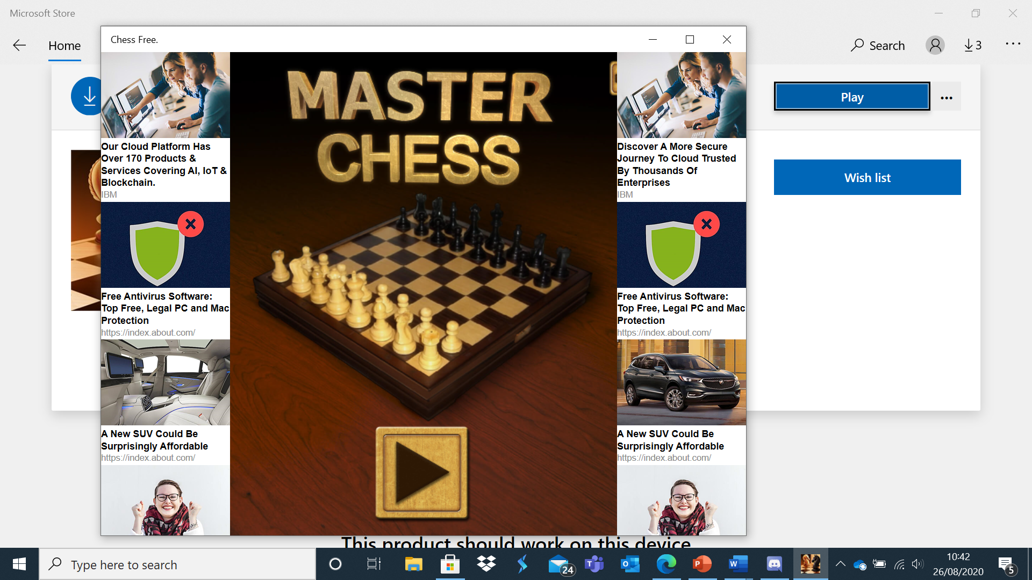

Right away, the game is full of intrusive advertisements.

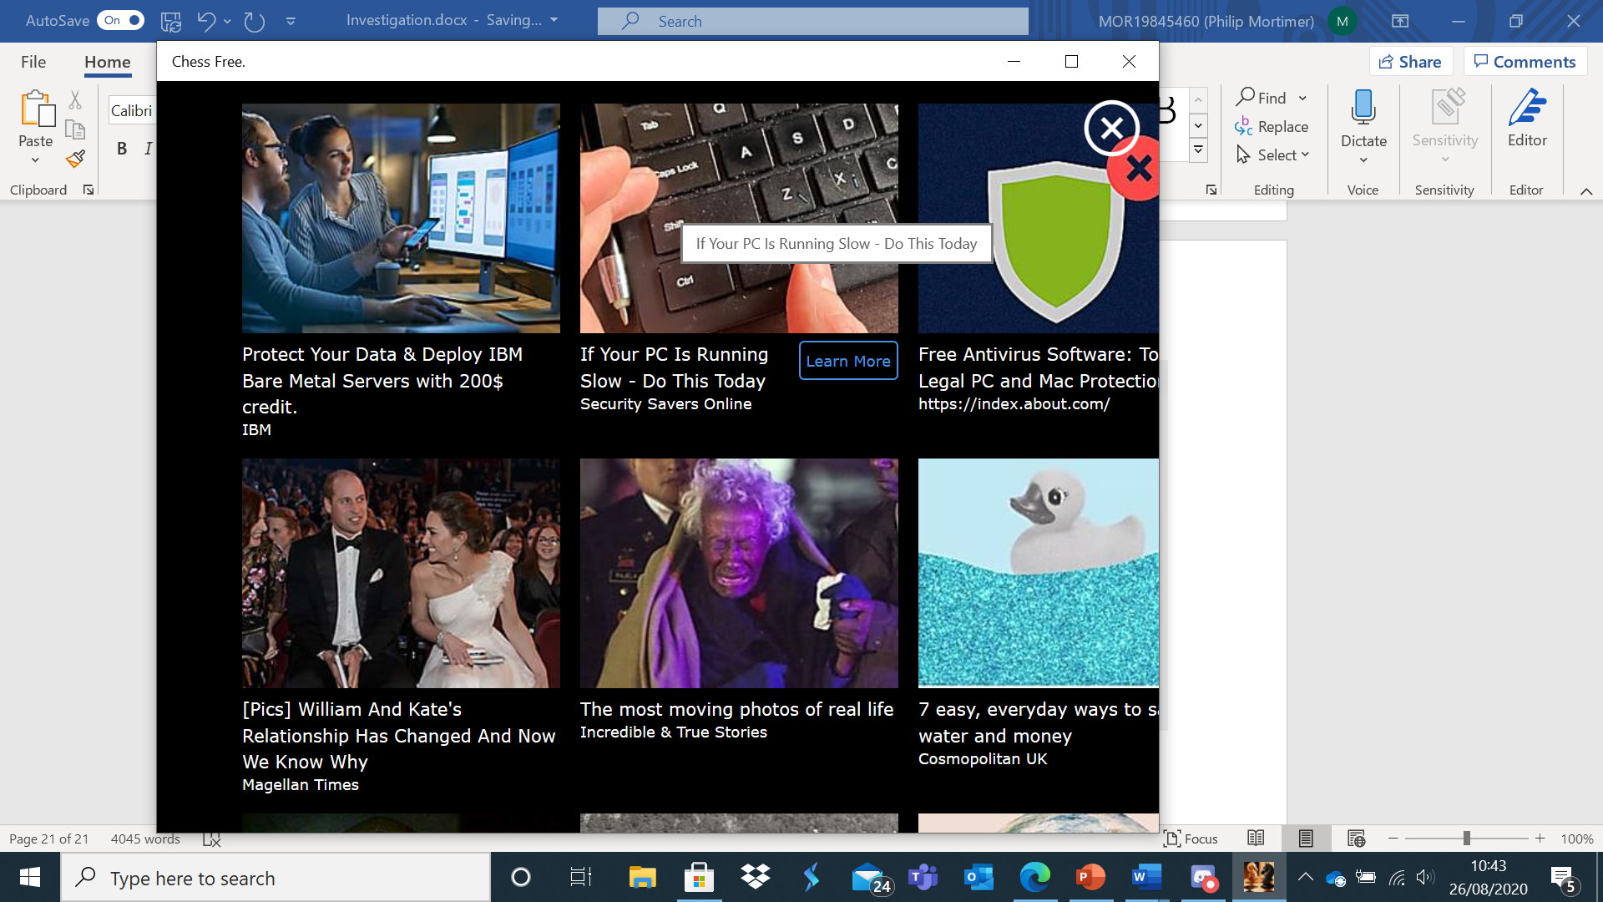

I found the game difficult to navigate as adverts kept appearing.

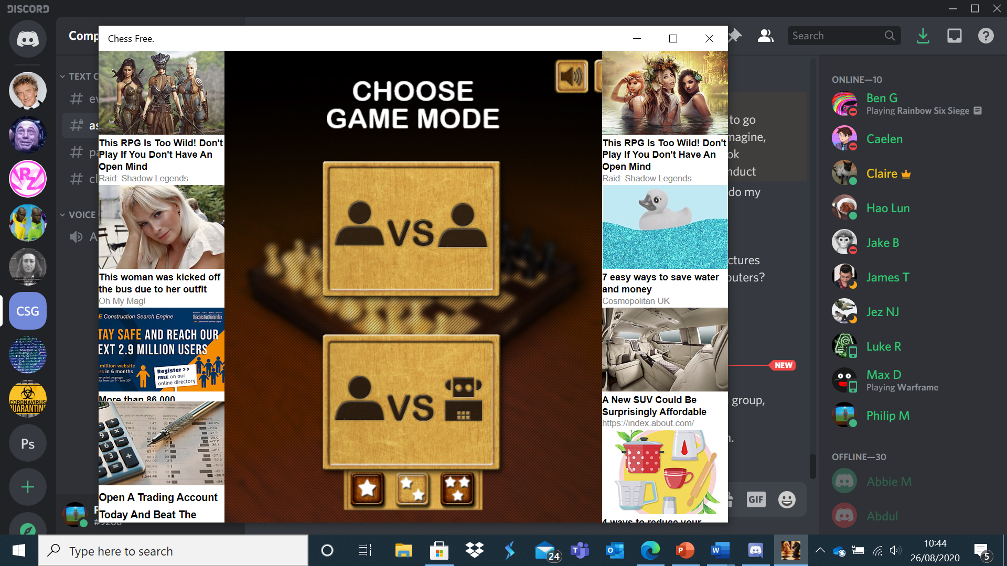

The game only supported two methods of play, person versus person and person versus computer. No online play features were implemented. The game appeared to have three difficulty settings, which, as established by my questionnaire, is probably too few, with 5 being a more appropriate number. There were also no customisation options for the ruleset, another noticeable missing feature compared to chess.com and Lichess. The game featured a 3d chess board which in my view looked tacky and simply inferior to the much cleaner aesthetic of a 2d chess board. However, the simplistic menus system was appreciated, particularly as navigation was easier than chess.com’s cluttered interface.

Next, I looked at The Chess Lv.100, the most downloaded chess application on the windows store.

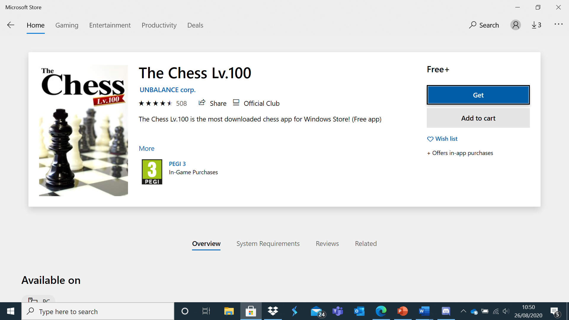

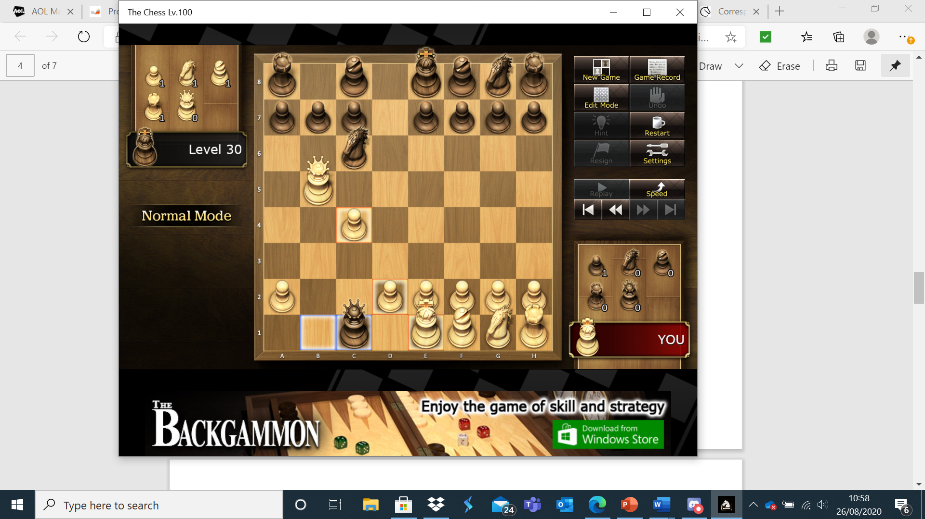

This game also only supports offline play; however, it features 100 different difficulty settings to play against. Furthermore, the game plays highly relaxing classical music whilst playing, a feature that led to me having a highly positive experience. Therefore, I plan on looking into adding music to my application although it may be difficult to find appropriate copyright free music. If I did add this feature, I would add the option to turn it off.

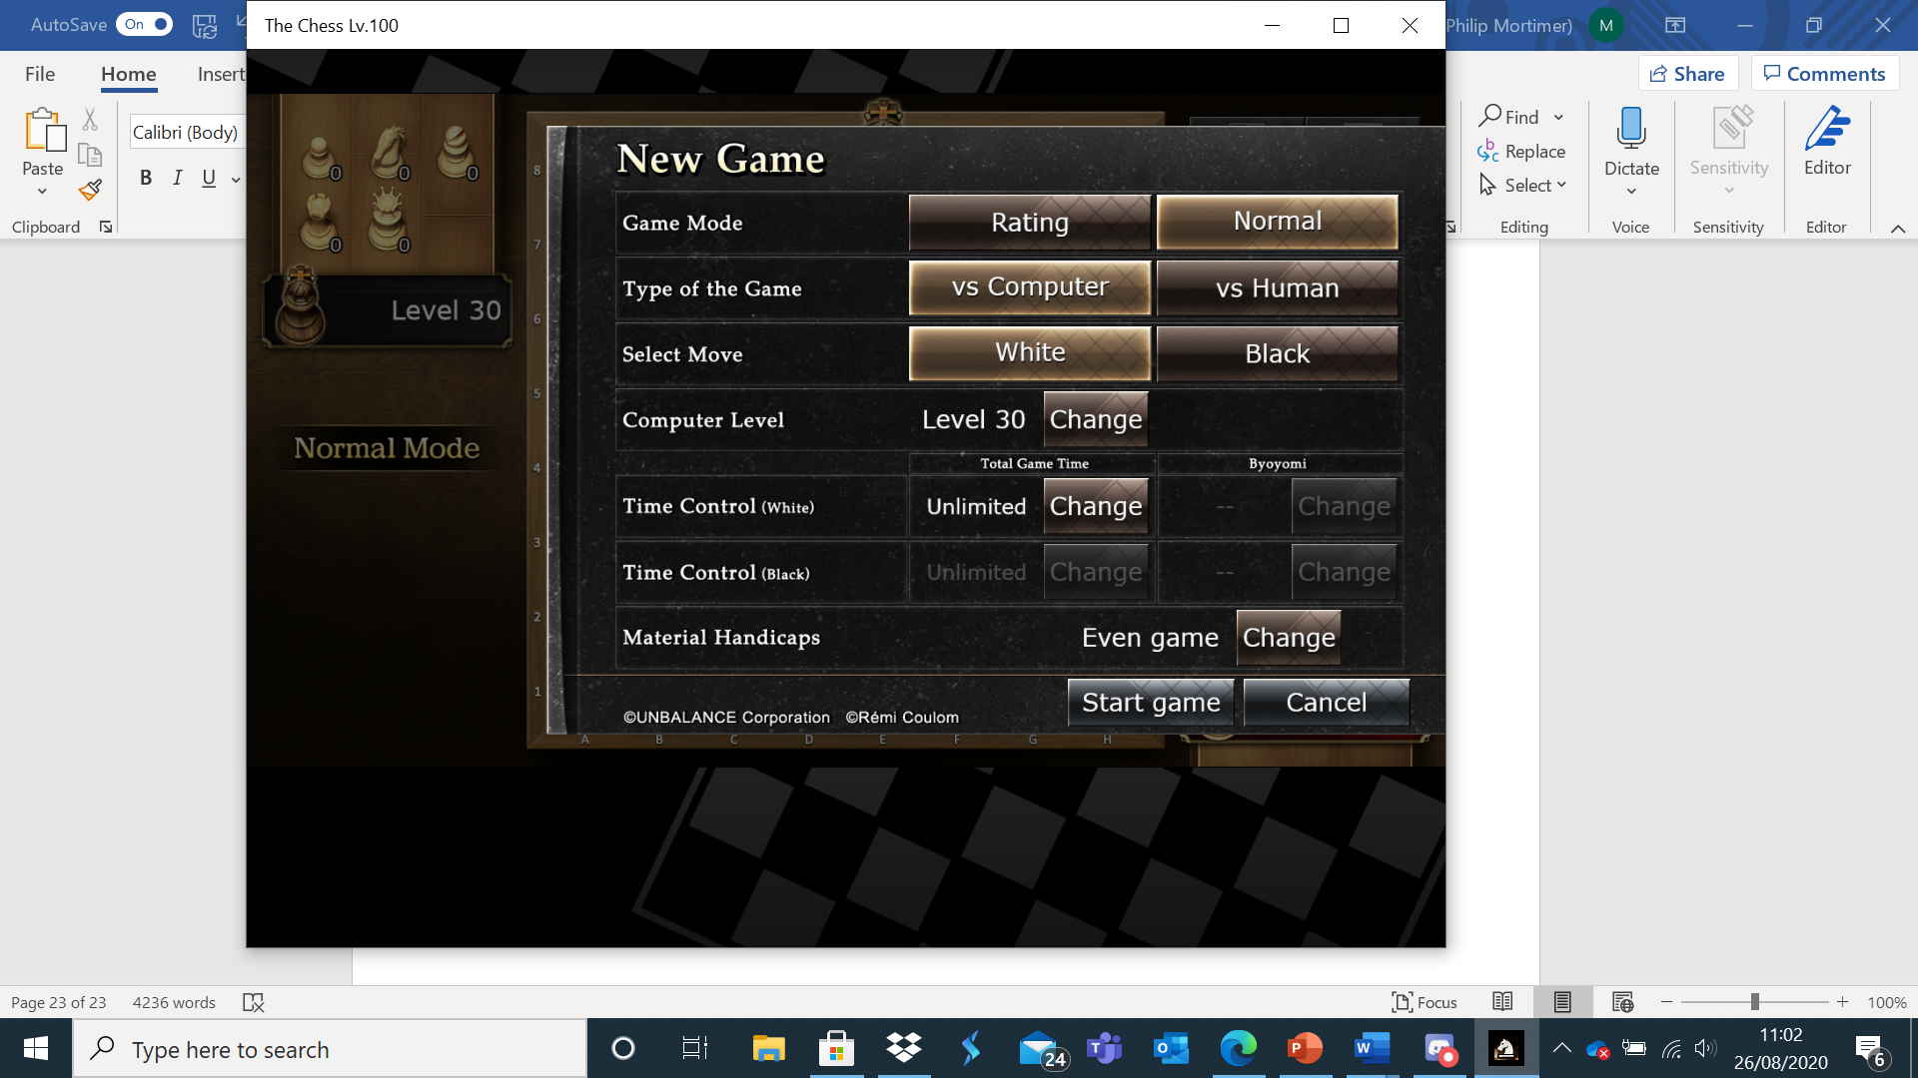

I am also impressed at how customisable the game is and I will definitely strive to make my game as customisable as possible, similar to this software. I will also have the option for multiple time controls in my chess game to allow both casual and competitive play.

I have produced a list of features from each system that I enjoyed and plan to include in my system. These features are highlighted in green. Features I do not plan to include are highlighted in red.

|  |  |  |  |
| --- | --- | --- | --- |
| Chess.com | Lichess.org | Chess Free. | The Chess Lv.100 |
| Top down 2d view of board | Top down 2d view of board | Top down 3d view of board | Top down 3d view of board |
| Control system – click on piece to get all available moves and then select one of the available moves | Control system – click on piece to get all available moves and then select one of the available moves | Control system – click on piece to get all available moves and then select one of the available moves | Control system – click on piece to get all available moves and then select one of the available moves |
| Cluttered menu with lots of icons | Ability to play against friends online – even when not logged in | Advertisements | Relaxing music that can be turned off or on |
| Ability to play correspondence chess | Clear menu with the option to play against friends being easy to access and very visible | Ability to play against friends and computer when offline | Customisable ruleset, including different time controls |
| The ability to view the previous board state | A relatively large range of difficulty settings for the computer | 3 difficulty settings for computer | 100 difficulty settings for offline computer |

Most of these programs have similar core features. All of them feature a top down chess board with a similar and intuitive controls system. They all allow local play against a computer or friend. The websites also support online play, a feature necessary for an online chess club. I have chosen to not include a 3d board as I found that it looks worse than a 2d one and as it would lead to the game being more resource intensive, something which should be avoided where possible. I also have chosen to include about 5 difficulty settings as 100 is far too many for me to program and also more than necessary for most users. Conversely, I found that three difficulty settings were far too few to use. I particularly enjoyed the relaxing music of Level 100 chess. Therefore, I shall attempt to add this feature, however, I may not be able to obtain copyright free music that is suitable (in which case, I would be forced to abandon the feature). The ability to view previous board states that both chess.com and Lichess provide is a feature which I found very useful when pondering what my next move was going to be. Hence, I shall have an option that allows the user to see what the previous board state was.

Lewis James also mentioned in his interview that he would like some form of ranking system to be implemented, citing the ELO system as one he would like to see implemented. I researched this system and found that it is probably the most used systems for chess rating. A player who has played no games starts at an arbitrary ELO rating (typically of 1000). When two players play each other, the probability of each player winning is calculated.

P1 = the probability of player one winning

P2 = the probability of player two winning

R1 = the ELO score of player one before playing player two

R2 = the ELO score of player two before playing player one

N1 = the ELO score of player one after playing player two

N2 = the ELO score of player two after playing player one

K = a constant number for score adjustment. This can be set to many different values and even change depending on rating of players. However, K will be set at 24, a normal value for a diverse skill range = 24

S1 = the score of the game from player one’s perspective. If player one wins, this value is set to 1. If player one loses, this value is set to 0. If player one draws, this value is set to 0.5.

S2 = the score of the game from player two’s perspective. If player two wins, this value is set to 1. If player two loses, this value is set to 0. If player two draws, this value is set to 0.5.

With all that defined, here are the relevant formulae:

P1 =

P2 =

N1 = R1 + K*(S1 – P1)

N2 = R2 + K*(S2 – P2)

Analysis of Current System

Currently there are two systems that are used by the club, chess.com and the organisation / Discord system.

Chess.com requires a username, email address and password to create an account. These details are validated (e.g. to make sure username and email address are unique). The email address is verified by the user. Then the user is required to log in to their account. The user goes to the play tab and requests a hyperlink from chess.com to set up a game. The chess.com servers process this request along with the username of the person requesting the link and returns a link. This link is then sent to the member they are playing against, via Discord, who clicks on it and logs into their chess.com account. The chess.com server verifies this and logs them on. Then each time a move is made, this data is sent to the chess.com servers who update the board state for both people. This carries on until the game is finished when chess.com displays the outcome of the game.

Each member also has to create a discord account with an email address, username and password. These inputs are also validated. Using discord, one member sends the generated hyperlink to the other member they are due to be playing. The other member clicks on the hyperlink. Once the game is over, the members message Lewis James with the result of the game.

In terms of the organisation system, Lewis James publishes the league table and schedule every other week on a Discord server that all the members are part of. He organises the table and fixtures himself. He stores the number of wins, losses and draws a member has accumulated across the season and uses these three things to determine the number of points a user has. Number of points = number of wins * 3 + number of draws. Once the number of points for each person has been calculated, the table is updated and ranked so that the person with the most points is at the top and so that the person with the least points is at the bottom. Lewis James generates the schedules so that everybody plays each other exactly twice. If a new member joins, they start on zero points and the fixtures are updated from that point on. However, matches are not replayed to catch up on games that a new member may have missed. If there are an odd number of participants, one member each week is given a pass where they get given three points automatically. A member will only have two pass games in the entire season (assuming there is an odd number of members).

So, data collected for input is typically a member’s username, email address and password. Chess.com also collects the move made by the user for input. The user details are validated and if they are valid, the details are stored on the chess.com user database. Each time a move is made, this move is sent to the other user whose board is updated to match this. Every board state is checked to determine whether it is terminal (i.e. win, draw or loss) and if it is, an appropriate message is displayed to both users. Discord also collects a member’s username, email address and password and validates these, updating their user database if the details are valid. Once a person has logged in, they can send messages by specifying the username of the member they wish to message. Discord then sends this message to that member. Furthermore, Lewis James puts all the members in a Discord server (a collective chat room) where he displays the table and fixtures. Lewis James uses all the member’s names and results to update a league table and generate the fixtures. Whenever a piece is clicked on, chess.com calculates all possible moves for that piece to make. The squares that the piece can move to are then highlighted. Clicking one of the highlighted squares is how the user moves their piece.

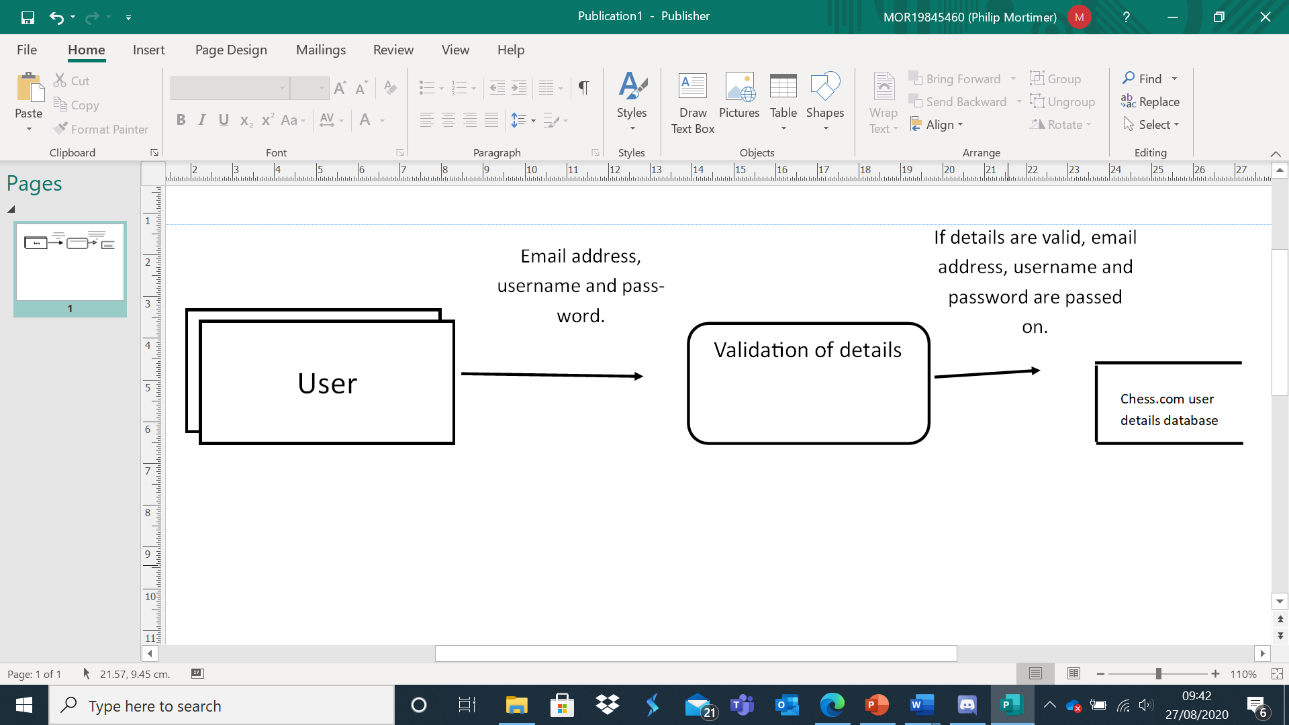

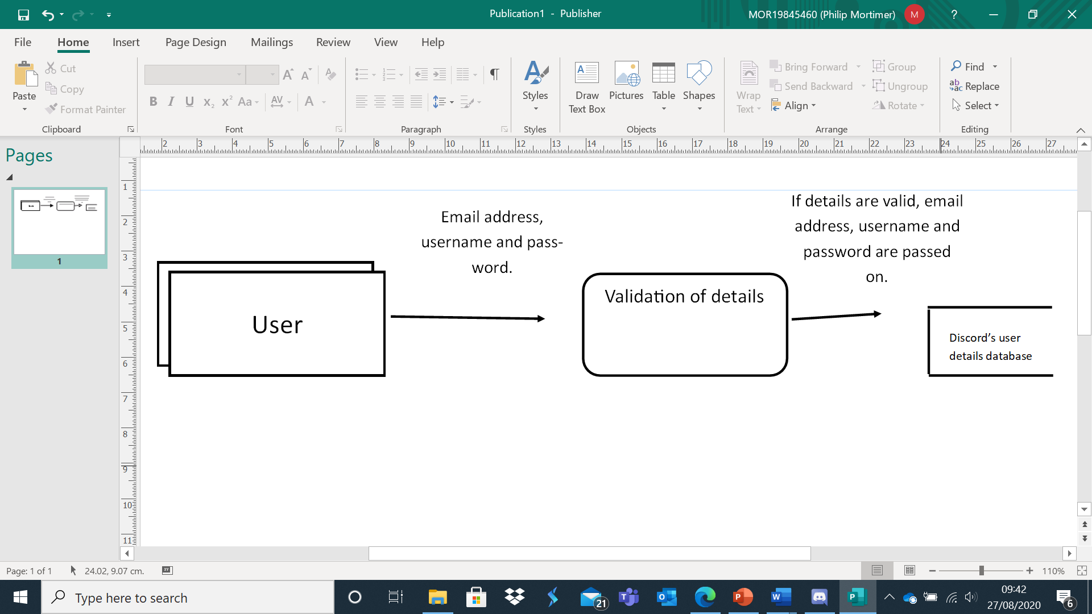

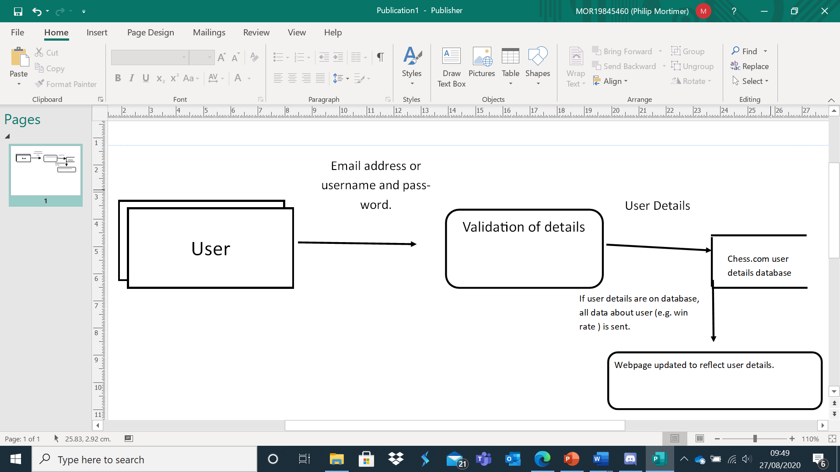

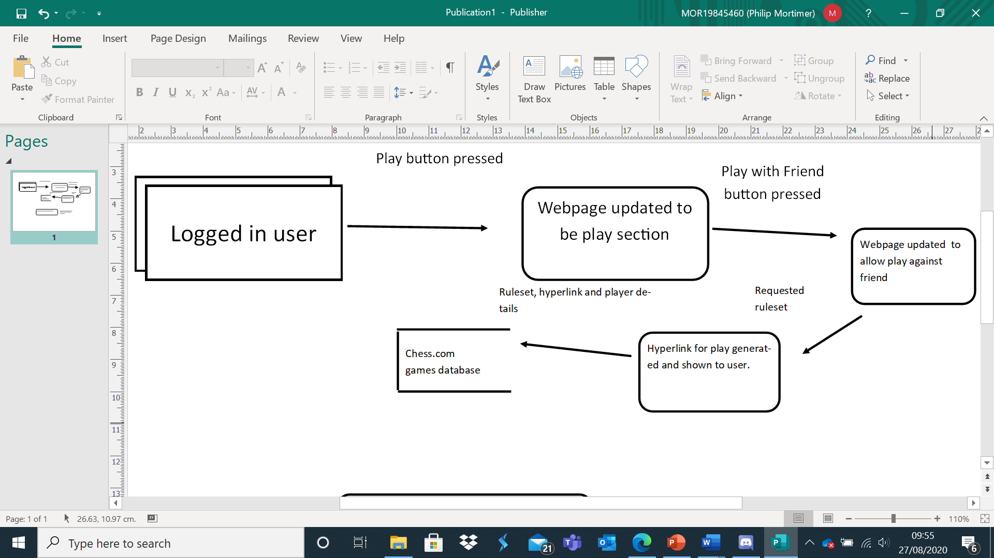

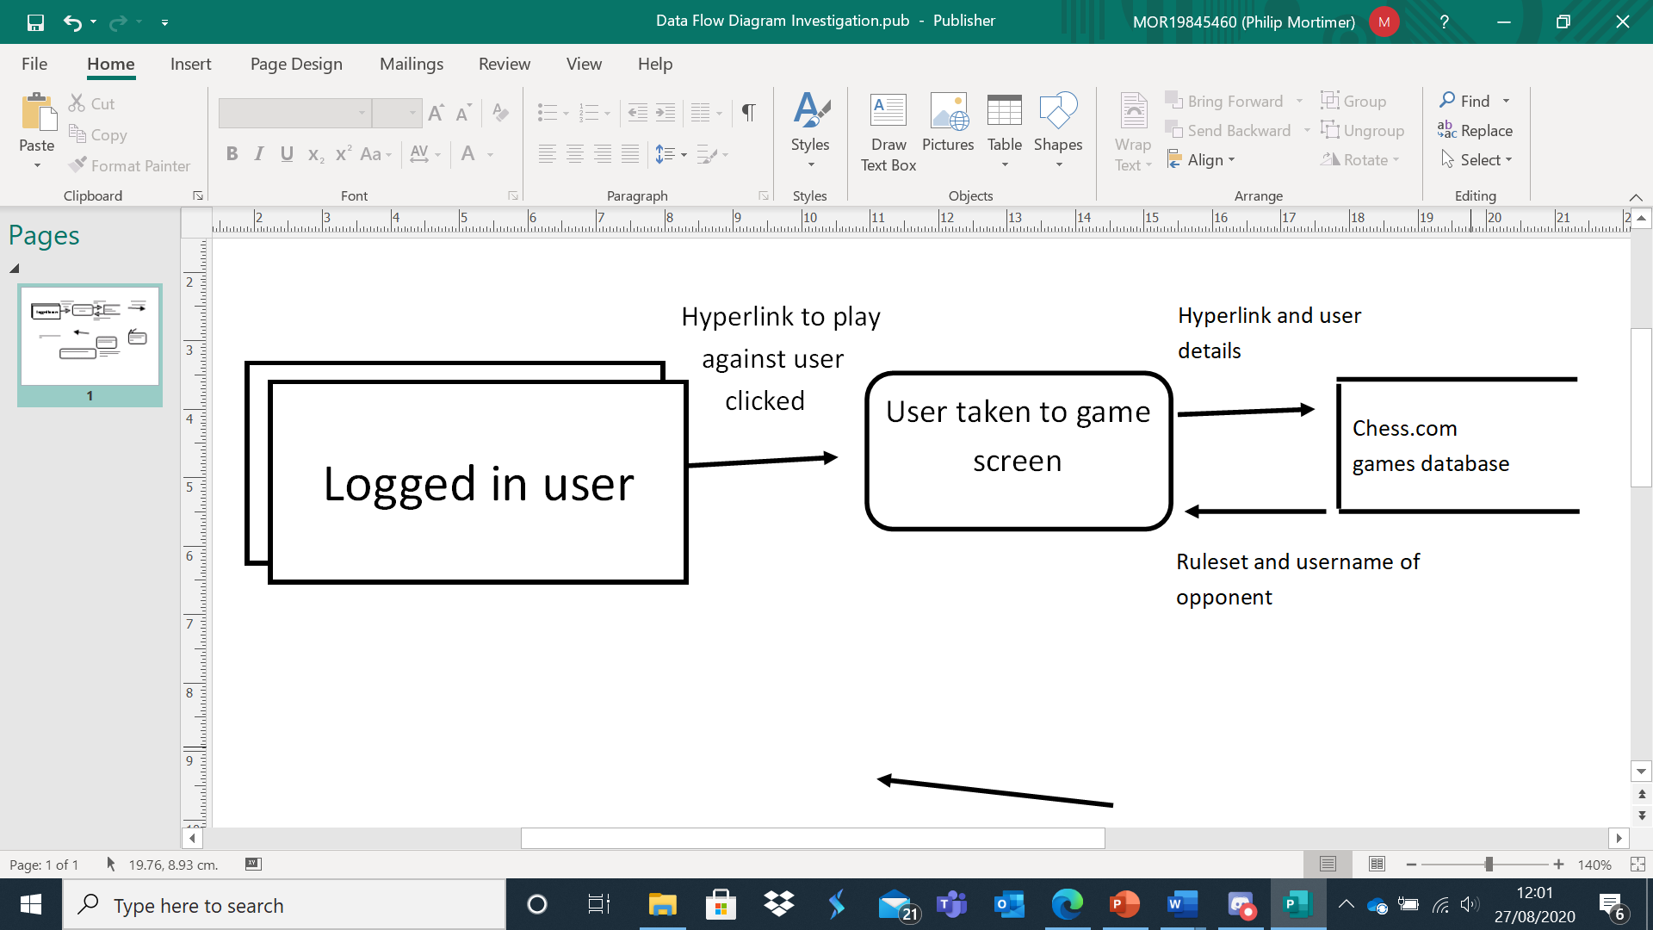

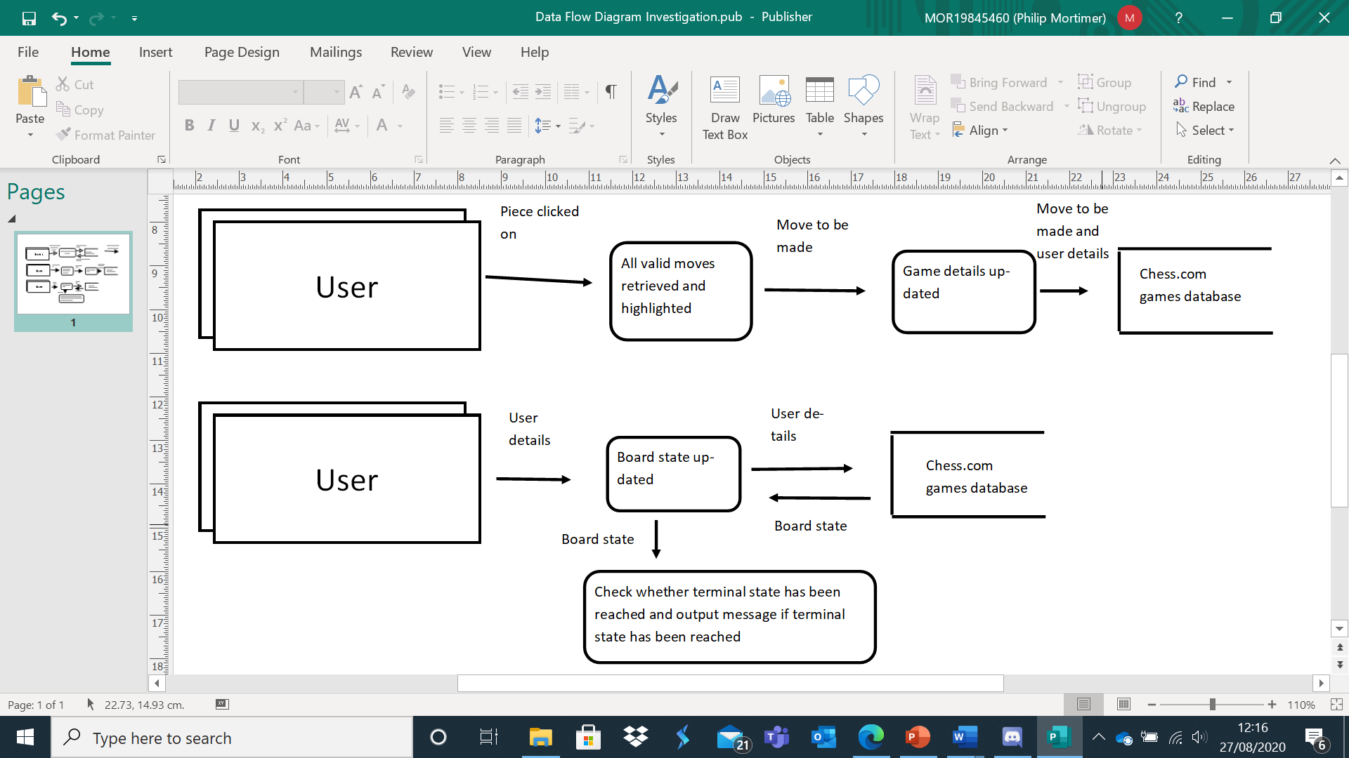

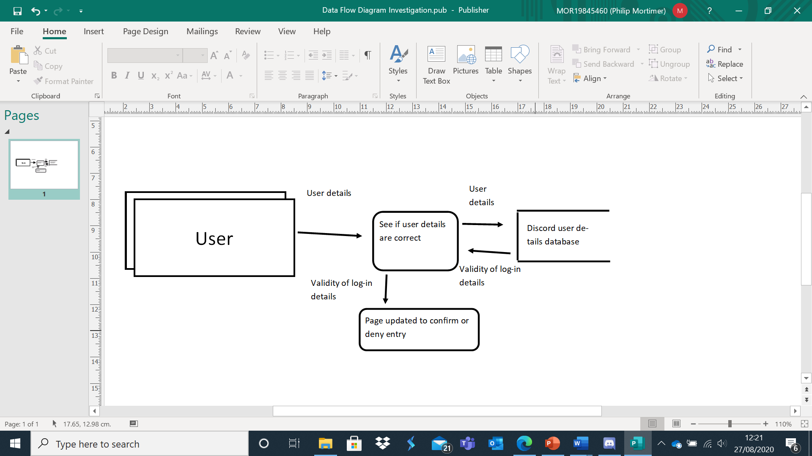

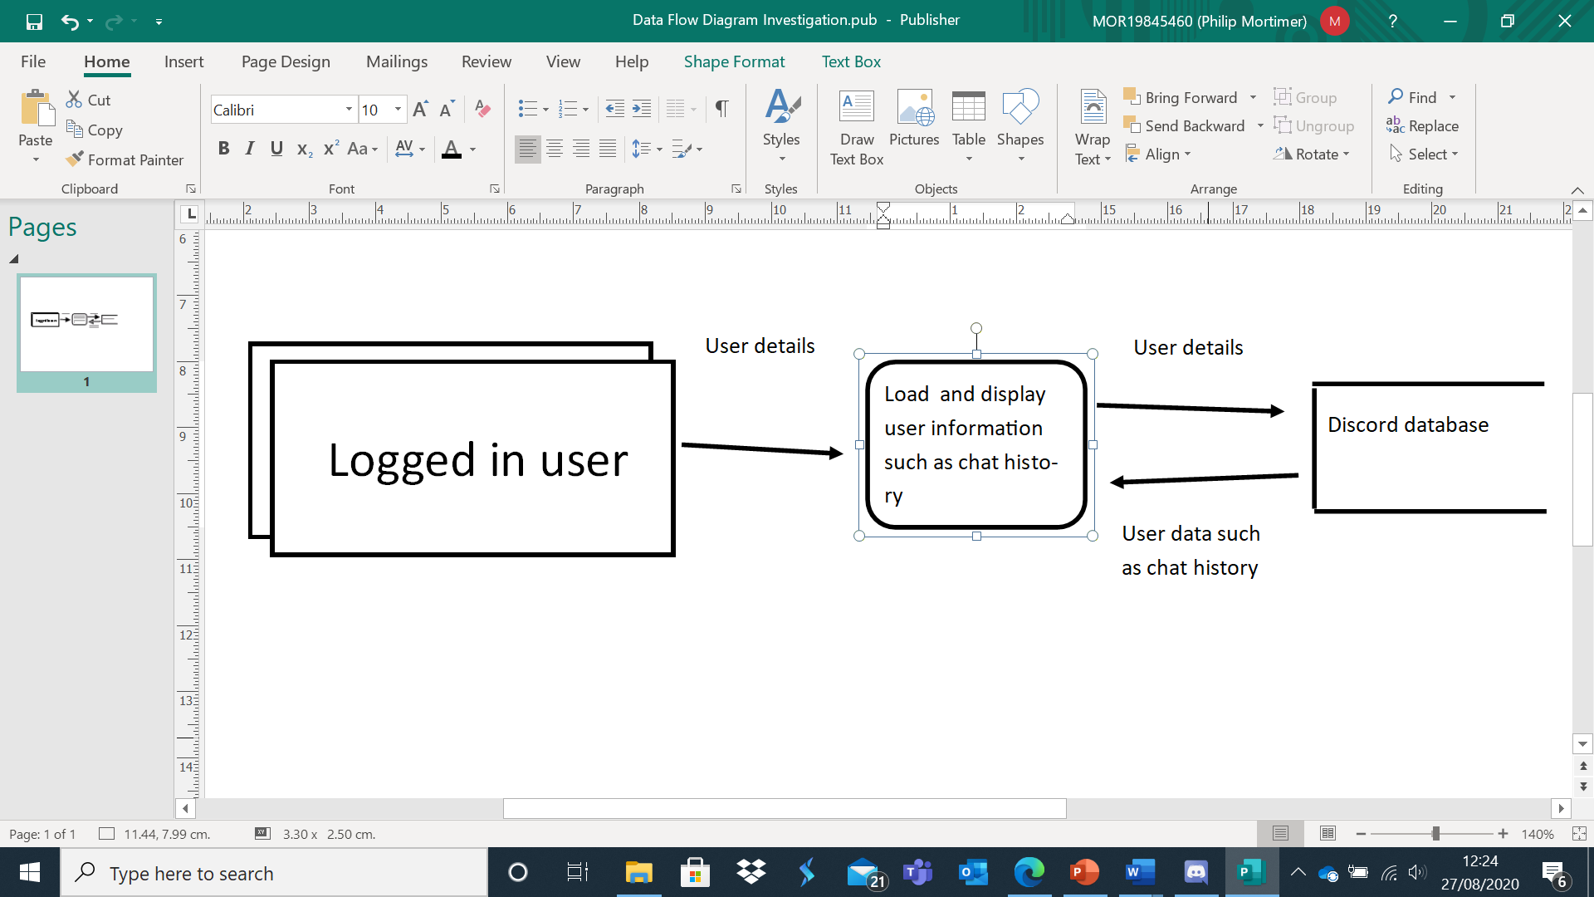

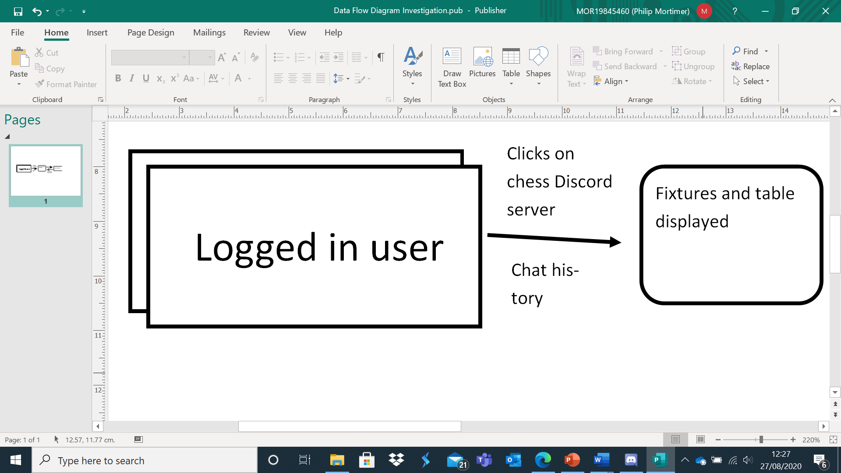

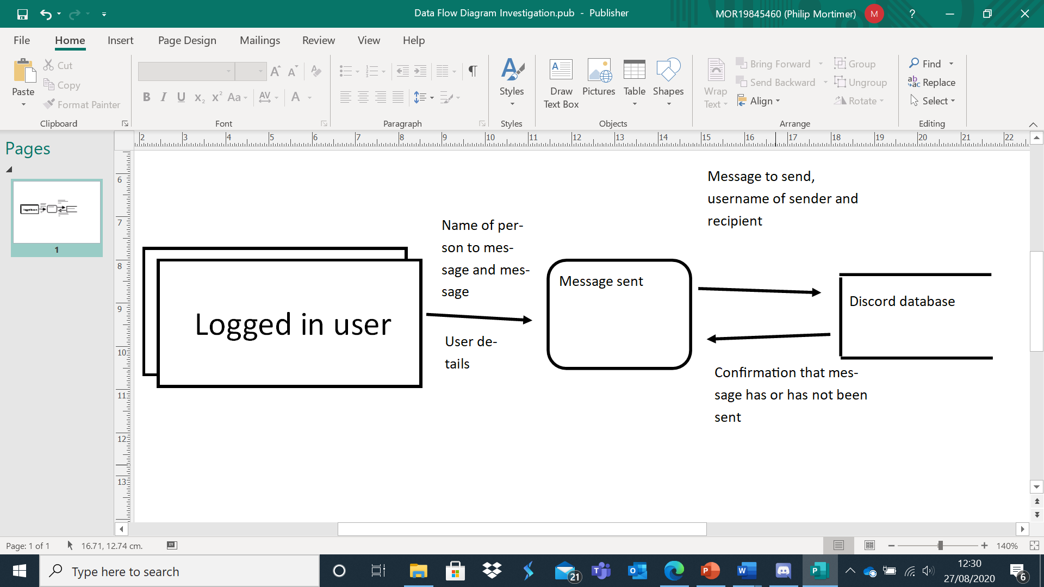

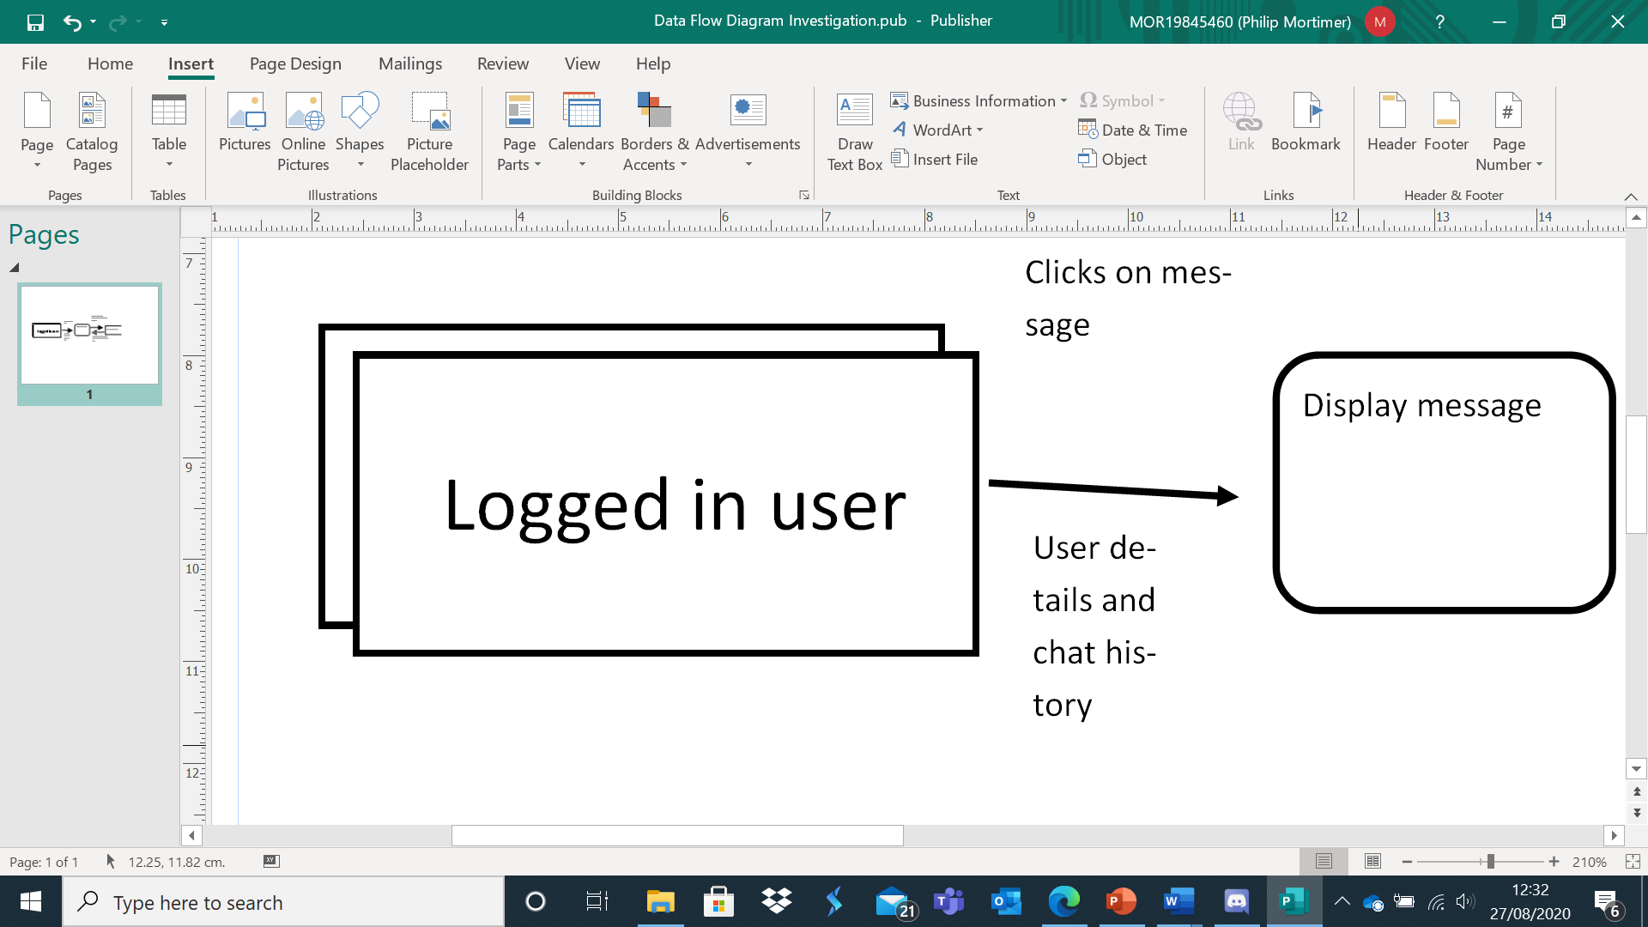

Limitations

The current system has numerous limitations. As the software used is not bespoke, it contains a range of features that members have no need for, which some felt led to the chess.com menu being hard to navigate. Most users reported that the experience of playing the game itself was good, but some members accidentally exited the game by closing a tab, something which could be addressed with simple verification that a user wishes to exit (ie. “Are you sure you want to exit?”). The lack of ability to play against a friend as a guest is also a limitation as it requires users to remember their username and password. Admittedly this is a minor hinderance, but one that systems such as Lichess.org manage to overcome. The most major drawback of chess.com is difficulty using it and its somewhat steep learning curve. For example, it took me multiple attempts for me to successfully set up a match against a friend as I accidentally closed the wrong pop up menu. Therefore, it is important for my system to be very easy to use. The system is limited outside of chess.com use as the way matches are scheduled is inefficient (i.e. Lewis James manually schedules them). Members report confusion over who should generate the hyperlink for the match and many found it inconvenient to use Discord to look at the fixtures and table. The current system is flawed as it requires Lewis James to physically update the table and members submitting their results, something which could easily be addressed by implementing an automated computer system that updates the table and collects the results of games. This would save Lewis James a lot of time and leave less confusion for members when viewing the table and fixtures as it would be in a more accessible and obvious place. Furthermore, if a new member joins the chess club midway through a season, Lewis James would have to manually update the fixtures – something which takes a long time and is hard to calculate manually. Chess.com is also flawed due to it being a website as an internet connection is required to access any of its features. A desktop application would allow users access to offline modes such as play against a computer, regardless of internet connectivity. Both Discord and chess.com are limited as they require the user to create and generate a password and username which are needed to access their features. The systems also collect more data than is necessary, such as analytical data for targeted advertisement, something which users may not be in favour of. Furthermore, chess.com locks certain features behind a pay wall and automatically sends promotional emails to registered users, something which can be annoying. From a user perspective, the viewing of the league table and fixture list is highly inconvenient and unclear, something which could be solved by a bespoke system. The current system is also dependent on third party servers and would be broken if one of these third-party servers was taken down or failed. Furthermore, members need to use two separate items of software to attend the club, including Discord which is computationally expensive (something which people with less powerful computers may notice).

**Confirmatory Interview**

Following my investigation into the current system, client requirements and existing solutions, I scheduled a follow up interview with Lewis James. In this interview, I presented him with the proposed specification based on what he identified as features he would like for the system and asked for his opinion on the features and whether he would like any additional features, features altered or features removed. However, I found that my proposed specification was fully accepted by Lewis James. James did request that the club member had the ability to make somebody else club leader, should James ever want to stop partaking in the club. He also said that the system should display contact details for the West Cross Chess Club and that these details should be able to be updated by the club leader. Specifically, he wanted an email address and phone number to be displayed. Here is a transcript of that interview.

Philip Mortimer: Hi Lewis!

Lewis James: Hey there again.

Philip Mortimer: So, I’ve considered what you’ve said and have come up with a proposed specification for the system to meet your requirements. I’m just going to run you through what I’m proposing. If at any point you don’t like something, want something changed or whatever just say. This system has to do what you want it to, so say if you want something added or are unhappy with anything.

Lewis James: Of course.

Philip Mortimer: So, what I am proposing is a system that allows users access to typical chess features. Users would be able to play against random people and friends online. Friends would play against each other by sharing a unique code. Users would also be able to play offline with friends or against a chess computer opponent of varying difficulty settings. Users would be able to access some of the features of the system without logging in, by playing as a guest. Users also have the option to create an account by submitting details such as their email address. There would also be a section devoted to the West Cross Chess Club. Users can request to join the chess club. The leader, currently you, would be able to accept or deny such requests as well as invite people to join the club. You would be able to view details of members such as email address or Discord username. You will have the ability to remove members from the club and alter their details. The system will schedule games every other Tuesday and collect the result of these fixtures to update the league table. Members will be able to view the table and fixtures. All fixtures would be directly accessed via the fixtures section of the club. The game of chess will play similar to something you would find on chess.com with a 2d view of the board. In order to enable online functionality, you would need to run a server constantly on a computer. Each user will also be ranked by the ELO rating system.

Lewis James: Ok. That sounds really good. Do you have the option to select different rulesets?

Philip Mortimer: Users will be able to select different timing settings and which side is what colour.

Lewis James: That sounds brilliant. I was wondering whether the system could display the contact details of the club and whether I could have the option to change the details if I want.

Philip Mortimer: Yep I will implement that. Any other thoughts?

Lewis James: I mean it sounds very good overall. I would also like to have the ability to make another user club leader in case I ever quit the club.

Philip Mortimer: Awesome. Anything else?

Lewis James: Nope, that all sounds right.

Philip Mortimer: Ok then, thanks for your time Lewis!

Lewis James: No problem.

**Specification**

1. The system will allow users to log in by providing an email address, username, and password. Both the email address and username must be unique.
2. Players may choose to play as guests who require no passwords but will have more limited features available to them. Guests will be unable to access features such as the club section but will be able to access offline play.
3. There will be an option for users to play online against random people or against friends. People can play against friends by typing in their friend’s username or by sharing a random 6-digit code generated by the system. Users will be able to customise the rule set for online play to allow for correspondence play and playing on a timer.
4. Users will be able to play chess locally against each other with users using the same computer to play against each other.
5. Users will be able to play against a computer of 5 levels of varying difficulty, which should range from easy to challenging.
6. When playing against the computer or locally, the user should be able to customise timer settings and decide who is what colour.
7. The system will have a West Cross Chess Club section where Lewis James will have the ability to add, edit and delete member details.
8. Users will be able to request to join the club, a request which the leader can either approve or reject.
9. The West Cross Chess Club section will generate the fixtures and users use this section to play their allocated games against each other. The computer automatically gathers the results from the scheduled games and updates the league table accordingly.
10. When all the club league games have been played, the system displays the winner and resets the table and fixture list.
11. Lewis James will have the option to make another user the club leader if he no longer wishes to be in charge.
12. The chess game will feature a two-dimensional chess board which allows users to move by clicking on a piece and then choosing from all available moves. The interface should be visually pleasing and clear and should highlight available moves and which piece has currently been selected.
13. The menu system should be clean and visually clear, containing a small range of options which allow the user to perform the tasks they wish to.
14. The system will have a constantly running server application which handles online play and user log in. The server will store all member details, as well as West Cross Chess Club details such as the table as well as a text file containing all ongoing games. The system will communicate with the server to facilitate online play.
15. The system will feature contact information for the club and the leader (currently Lewis James) will have the ability to update this information.
16. The system will rank players via their online play results using a ratings system known as ELO.
17. When playing online, the system will display both users’ username and ranking.

**Technical Justification**

I shall be using the Java programming language for the system. Java is useful as it uses a virtual machine to execute its code, this means that the code is portable and can be used by Linux, Windows, and Mac users. As all club members own a computer, all of the members should be able to run the application. Furthermore, I am familiar with Java and believe that its features make it an ideal candidate for the system. For example, Java’s ability to multithread is ideal for displaying a timer (something needed in chess). Object oriented programming is highly useful in a range of contexts and would be useful in creating a game object, for example. Java’s built in socket class is useful for networking and communicating with a server (something which I am doing in my project). Java also supports exception handling, an important feature in many instances, such as checking to see if something is an integer. Exception handling also enables code to continue running if an unforeseen error occurs. This could be important for the server application which may disconnect from the internet momentarily.

I will create the graphical user interface using the javax.swing library which supports easy to use GUI elements such as JFrames. This will make it easier to create a visually clean and satisfying menu as it supports both drag and drop creation as well as programmatic creation, allowing both precision and creative freedom. I plan to make use of JLabels for each square of the chess board as they are square shaped, unlike JButtons which have curved edges. I shall make use of the ability to set the icon of a JLabel to display the actual pieces. I shall change the colour of a square to show that it is highlighted.

I shall develop my solution using the NetBeans 8.2 IDE as it allows for me to preview the jaxav.swing GUI and drag and drop to build the interface. The IDE is also used as it provides useful colouring of key Java syntax which helps minimise the number of errors made. The IDE will highlight instances of incorrect syntax or likely errors, further aiding to minimise bugs. NetBeans has a range of debugging features such as break points, variable watches, and error messages.

My solution will be event driven as it is based on user interaction through a GUI, however I will make use of object-oriented programming in a few instances, such as through the creation of a game class that handles the game. However, most of it will be driven through user inputs such as making a move or logging in.

My solution will feature a centralised server that stores user details and in progress games. This is necessary as the club requires the ability to play against each other online, requiring networking. A centralised server is used to allow for members to log in and hence the system is able to automatically update the table. I have chosen to develop my solution for desktop users as my server indicated that all members owned a computer but that at least one member did not own a smartphone.

For my computer opponent, I shall use a range of factors such as search depth and heuristic for board value to alter the difficulty. However, an alpha-beta minimax algorithm will be implemented for all of these solutions. This is standard in chess software and allows for confident decision making that evaluates all options at a given depth. More advanced heuristics will use positional data in combination with piece value to calculate the board value of a given state. I have chosen five difficulty levels as questionnaire results indicate that three levels may be too few, particularly as the club are mostly below-average at chess (making differing degrees of lower difficulty opponents important).

My data will be normalised to minimise data redundancy which both reduces the amount of storage and drastically decreases the likelihood of errors occurring as data only needs to be updated in one place as opposed to multiple.

**Objectives and Success Criteria**

In this section, I will give the relevant specification item (which is numbered). For each specification item, I will provide a set of objectives (represented alphabetically). For each objective, I will have success criteria (represented with roman numerals).

1. The system will allow users to log in by providing an email address, username, and password. Both the email address and username must be unique.
   1. To create a database that stores all relevant details, including user details, in the third normal form.
      1. All data stored must have no repeating groups, partial dependencies or transitive dependencies.
      2. Users will be able to log in to the system by providing their email address / username and password. Once logged in, they will be able to view their details such as their ranking or fixtures (if they are a member of the club).
   2. To check that both the email address and username provided are not already the username or email address of another user. This will be done by searching the file storing all user details.
      1. When attempting to create an account, users who input the email address or username of another user will be unable to use that name and will be asked to choose a different one.
      2. When creating an account, a username / email address that has not already been used by another user should be accepted.
   3. To search both user email address and username to find a match when logging in.
      1. Users should not be able to create a username that could be a valid email address. This will be achieved by not allowing @ character in usernames and requiring the @ character in email addresses.
      2. Users will be able to log-in by providing either their email address or username.
2. Players may choose to play as guests who require no passwords but will have more limited features available to them. Guests will be unable to access features such as the club section but will be able to access offline play.
   1. When a guest uses the system, they will be given one id that all guests have. This id will be impossible for a normal user to have. With this guest id, the guest will have the ability to play offline games but will not have a ranking or the ability to continue offline games over multiple sittings. Hence, the system will have four access levels (for guests, users, club members and the club leader).
      1. A guest will be able to play offline but will not be able to access the club section. They will be unable to play games over multiple sessions.
3. There will be an option for users to play online against random people or against friends. People can play against friends by typing in their friend’s username or by sharing a random 6-digit code generated by the system. Users will be able to customise the ruleset for online play to allow for correspondence play and playing on a timer.
   1. The server will have a text file storing all currently ongoing online games. Each time a new game is created, a game id will be generated for it. This will be the six-digit code that users can share. Furthermore, it will store details such as the board state and the user id of players, as well as the ruleset.
      1. Users will be able to play against friends either by sharing a six-digit code or by typing their username. The ruleset for these games will be customisable.
   2. Players will be able to play against random people by pressing a button. They will be matched against another user who also wishes to play online. If nobody wishes to play online, the system will tell the user that no match could be found. This will be achieved by having the server store the user id of all players who wish to play against a random person. When two ids are found, they will be matched and have a game started.
      1. Users will be able to play against random opponents when they can be found. If no opponents can be found, an appropriate message will be displayed.
4. Users will be able to play chess locally against each other with users using the same computer to play against each other.
   1. A file containing all ongoing offline games will be stored. This will store up to three current games. When a file is clicked on, the game is resumed.
      1. Users will be able to play up to three offline games at a time over multiple session.
   2. Users will be able to play offline and customise the time controls. Each offline game will be given a game id.
      1. When creating a game, users can choose which time control they would like to use. This time control will then be used for the game. This includes the option for no time restrictions.
5. Users will be able to play against a computer of 5 levels of varying difficulty, which should range from easy to challenging.
   1. I will use a depth limited alpha-beta pruned minimax algorithm to deduce which moves should be made. The varying difficulty will come from use of heuristics of different complexities in combination with different search depths.
      1. I will play each of the computer algorithms and rank them in order from easiest to most difficult. Then I will have the computers play each other. If my ranking is the same as the ranking obtained from playing the computers against each other, I will have clearly succeeded in creating five distinct difficulty settings.
6. When playing against the computer or locally, the user should be able to customise timer settings and decide who is what colour.
   1. Create a visual menu that allows the user to select from a range of a time controls, including unlimited and the FIDE official timer control settings. Users will also be able to decide what level of computer to play against and whether the computer is white, black or random. These settings will be stored, and a new game will be created
      1. A user should be able to play local games using various different time controls and against a computer of varying difficulty. This can be verified by testing how long it takes for a user to lose due to running out of time.
7. The system will have a West Cross Chess Club section where Lewis James will have the ability to add, edit and delete member details.
   1. The server will store details of all club members in a table that is in the third normal form. Lewis James will be able to retrieve and view this information. He can then edit user details, which will be updated on the server. He can also remove users from the club or add users to the club. This will be achieved by updating the file on the central server.
      1. The club leader will be able to view all member details and edit these. The leader will also be able to remove or add members to the club. This can be shown to have been successful by viewing club details after changes have been processed.
8. Users will be able to request to join the club, a request which the leader can either approve or reject.
   1. Users who are not a member of the club will click on the club section and have the option to send a request to join the server. If they choose to send the request, the request will be sent to the server. The server will then store this request. The leader, currently Lewis James, will then have the option to allow these members to join the club or to reject the request.
      1. Users will be able to request to join the club and Lewis James will be able to see these requests. Lewis James will then either approve or deny these requests. This can be verified through testing by sending a request and seeing if it shows up for the leader. Then, the leader will accept the request. If the user who requested to be a member is now part of the club, the objective will have been fulfilled.
9. The West Cross Chess Club section will generate the fixtures and users use this section to play their allocated games against each other. The computer automatically gathers the results from the scheduled games and updates the league table accordingly.
   1. The computer will use the list of current members to generate a fixtures list for the season. If new members join the club halfway through the season, the remaining fixtures will have to be updated to allow the new member to play.
      1. If the system generates fixtures in a way that each user plays each other exactly twice and so that every game occurs every other Tuesday, the algorithm will have succeeded.
      2. If new members join the club when there are 3 games (for example) left of the season, the new member should still be able to play those remaining three games.
   2. The user will be able to view their fixtures in the club section. They will then start a new game with the member they are schedule to play against for that week.
      1. The user will view their fixture in the club section and be able to play the game there. The result of the game will be collected and lead to the league table being updated.
   3. The system will collect all results and use them to update the league table standings. The league table, which is stored by the server, can be viewed by players.
      1. Once fixtures have been played the league table should be updated to display the new scores and standing.
10. When all the club league games have been played, the system displays the winner and resets the table and fixture list.
    1. When the system reaches the end of the current fixture cycle, the league table is displayed along with a message that shows who won. The table is reset, and the fixture generation algorithm is run again to start a new season.
       1. When the end of the season is reached, a message should be displayed to indicate that the season is over.
       2. When the end of the season is reached, the table should be set so that everyone has zero points and the fixtures should be generated once more.
11. Lewis James will have the option to make another user the club leader if he no longer wishes to be in charge.
    1. The system will store the user id of the club leader. If Lewis James wishes to make somebody else club leader, he will need to know their username. The system will then set this users id as that of the club leader. This will allow the Lewis James to make somebody else the club leader.
       1. The current club leader will be able to transfer the role of club leader to another valid user. If they do chose to transfer the role, the user who they have transferred the role to will be able to perform all the task that only the club leader can perform (such as updating the club’s contact details).
12. The chess game will feature a two-dimensional chess board which allows users to move by clicking on a piece and then choosing from all available moves. The interface should be visually pleasing and clear and should highlight available moves and which piece has currently been selected.
    1. To create a GUI using built in features such as JFrame to display a visually pleasing chess board. The view will be a top down view of a two-dimensional board and will be similar to chess.com’s board. The control scheme must be very usable and intuitive.
       1. The board must feature a two-dimensional top down view and be visually pleasing. To test this, I will ask five members whether the board is visually pleasing and looks somewhat similar to typical two-dimensional top down boards (such as Lichess’ board). If all five members agree, I will have succeeded. I will also ask the members whether the control scheme is usable and intuitive also.
    2. When a piece is selected, the piece is highlighted, and the system calculates all possible moves for the piece to make. These possible moves will be highlighted.
       1. To test this, I will select each piece across multiple games and use my knowledge of chess to determine whether all legal moves have been identified.
13. The menu system should be clean and visually clear, containing a small range of options which allow the user to perform the tasks they wish to.
    1. I will use the built in NetBeans drag and drop GUI builder to create a clear and visually pleasing menu. The menu will be simple and contain a small range of buttons that allow the user to navigate to the desired section of the system.
       1. Navigation should be intuitive and easy, even for novice users. Text and buttons should be readable and large. To measure this, I will ask five members whether they find navigation easy and whether they find the menu clear. If all five agree, I will have succeeded.
14. The system will have a constantly running server application which handles online play and user log in. The server will store all member details, as well as West Cross Chess Club details such as the table as well as a text file containing all ongoing games. The system will communicate with the server to facilitate online play.
    1. The server application will be constantly running and will handle all elements of the club that are online. This includes the creation of accounts, user log-in, online play, storing chess club details, collecting fixtures results, updating the league table, storing the chess club leader and scheduling fixtures for the chess club.
       1. If players are able to log-in and perform online tasks such as creating an account or playing against a friend online, the objective will have been met.
15. The system will feature contact information for the club and the leader (currently Lewis James) will have the ability to update this information.
    1. There will be a section in the club tab, which will be accessible to all users connected to the internet (including non-club members), which displays the email address and phone number of the club. These details will be stored on the server and the club leader will have the opportunity to update these details.
       1. All users should be able to view the club’s contact details and Lewis James should be able to change these contact details.
16. The system will rank players via their online play results using a ratings system known as ELO.
    1. After each online game, the server will receive the result and calculate the new ELO score for each player following a set of formulae defined earlier in this document. The ELO rating of a player will be stored by the system and displayed alongside username when playing an opponent.
       1. After a game against an opponent, I will calculate what each user’s new ELO score should be and compare it to what the system determined they should be. If these scores equate, the system will have succeeded.
17. When playing online, the system will display both users’ username and ranking.
    1. When matching against an opponent, the server will store both users’ name and ELO rating. These will be displayed to the other user when playing online. These (and all) calculations should be correct and accurate.
       1. When playing online, users should be able to see both their username and ELO rating as well as their opponent’s rating and username.
18. GENERAL OBJECTIVES AND CRITERIA
    1. The system should be easy to maintain. I will achieve this through use of extensive documentation (e.g. comments in code to explain the purpose of methods). Bugs should be easy to identify and fix, something which I will achieve by designing the system in a modular fashion.
       1. A competent programmer should be able to recreate the system given its documentation.
       2. My system will be modular, making use of many independent methods. To test whether my system is easy to debug, I aim for users to encounter no more than three minor bugs in a session and no major bugs in an average session.
    2. The system should fully meet the requirements of the specification.
       1. I will ask Lewis James whether the system performs as he intends it to once I finish it.
    3. Validation should be employed for all appropriate fields of manual data entry.
       1. I will aim to catch at least 90% of invalid inputs.
    4. All calculations performed should be accurate and correct
       1. Calculations such as ELO rating should be accurate and all relevant success criteria relating to ELO calculation should be achieved. All other calculations should be correct, such as the updating of the league table.
    5. The system should be visually clear and easy to navigate. It should be easy to use, even to those unfamiliar with technology.
       1. I will ask chess club members whether they found the system intuitive and easy to use, and if they all agree, I will have succeeded.